Faculty Performance Based Appraisal System

**Submitted to**

**International Institute of Professional Studies**

**Devi Ahilya University**

**Indore  
 2017**

**For XII semester of**

**Master of Computer Applications (6 years)**

**Internal:** **Submitted By:**

**Acceptance from the guides To whomsoever it may concern**

I ________________________, working as ___________________________with

________________give my consent to guide _______________for a project titled

______________________________. The tentative duration for the project will be from _________to_________________.

Signed by

**Project Guide**

**Certificate from the company**

**(On the company’s letterhead)**

**To whomsoever it may concern**

This is to certify that Mr. /Ms. ____________________________has been allowed to carry a project titled ___________________in our organization. The duration of the project will be from __________________to _________.

Signature

**Authorized Signatory**

**Certificate of completion of project from the company**

**(to be submitted along with project report)**

(on the company’s letterhead in three copies and to be binded along with the report)

**To Whomsoever It May concern**

This is to certify that Mr./Ms. _____________________has completed project titled

___________________________________in our organization from date____________to_____________. His/her performance and conduct has been found satisfactory.

Signature

Authorized Signatory

**CERTIFICATE**

This is to certify that the project report entitled “**Faculty Performance Based Appraisal System**” carried out by (name with rollno)is approved for the acceptance in partial fulfillment of XII semester MCA (6years).

**INTERNAL EXAMINER EXTERNAL EXAMINER**

Name: Name:

Date: Date:

**DECLARATION**

I hereby declare that the project entitled “Faculty Performance Based System” which is submitted for the completion of the requirement for XII semester of Master of Computer Application (6 years), to International Institute of Professional Studies, Devi Ahilya Vishwavidyalaya, Indore. This work has not been submitted anywhere else and comprises of our own work and due acknowledgment has been made in text to all in other materials used.

Signature of Student

**ACKNOWLEDGEMENT**

I acknowledge my sincere thanks to those who have contributed significantly to this project. It is a pleasure to extend deep gratitude to our internal guide (faculty name), for his valuable guidance and support and to continuously prompt us for the progress of the project. I thank for her valuable suggestions towards our project, which helped us in making this project more efficient and user friendly.

I thank and acknowledge (frnd name) and(fn) for their efforts that helped me in some or the other way for small and significant things. Last but not the least I would like to thank my parents and family members for their enormous co-operation and support.

**ABSTRACT**

The project aims at developing an automated system designed to cater the requirements of co-operative society in the proper manage and automated way. It will be a tool to manage member information, registration of loan, installment of loan and reporting the information to the user in the desired format at right time. This step of automation will minimize paperwork, time and hard work of the members of society who manage this information.

**TABLE OF CONTENTS**

|  |
| --- |
| 1. **1. INTRODUCTION**    1. **: The Client Organization………………………….............**    2. **Problem Definition…………………………………………**    3. **Aim………………………………………………………….**    4. **Objective……………………………………………………**    5. **Benefits……………………………………………………...** |

**2. SOFTWARE AND HARDWARE REQUIREMNTS**

**2.1 Software Requirements**

**2.2 Hardware Requirements**

|  |  |
| --- | --- |
| **3. PROJECT PLANNING** | |
| **3.1** | **Project Scope …………………………………………………..** |
| **3.2** | **Documentation Plan ………………………………………….** |
| **3.3** | **Team Structure ………………………………………………..** |
| **3.4** | **Project Deliverables …………………………………………..** |
| **3.5** | **Gantt Chart ……………………………………………………** |

|  |  |
| --- | --- |
| **4 . CURRENT SYSTEM AND PROPOSED SYSTEM** | |
| **4.1** | **Current system ………………………………………………** |
| **4.2** | **Limitations of Current System …………………………………** |
| **4.3** | **Proposed system ………………………………………………….** |
| **4.4** | **Objectives of Proposed System …………………………………** |
|  |  |

|  |  |
| --- | --- |
| **5. FEASIBILITY STUDY** | |
| **5.1** | **Economic Feasibility ……………………………………………..** |
| **5.2** | **Technical Feasibility ……………………………………………** |
| **5.3** | **Behavioral Feasibility ……………………………………………** |

|  |  |  |  |  |  |  |  |  |  |  |  |  |  |  |  |  |  |  |  |  |  |  |  |  |  |  |  |
| --- | --- | --- | --- | --- | --- | --- | --- | --- | --- | --- | --- | --- | --- | --- | --- | --- | --- | --- | --- | --- | --- | --- | --- | --- | --- | --- | --- |
| |  |  | | --- | --- | | **6. SYSTEM ANALYSIS** | | | **6.1** | **Form……………..………………………………………………..** | | **7. SYSTEM DESIGN** | | | **7.1** | **Logical Design…………………………………………………...** | | **7.2** | **User Interface…………………………………………..............** |  |  |  | | --- | --- | | **8. SYSTEM CODING AND IMPLEMENTATION**  **8.1 XXXXXX …………………………………………………………**  **9. OUTPUT FORMS AND REPORT**  **10. SYSTEM TESTING** | | | **10.** | **1 Types of Testing** | | **10.2 White box and black box and Regression Testing(through Selenium).**  **10.3 TestCases**  **10.4 Bug Reports**   |  |  | | --- | --- | | **11. FUTURE PROSPECTIVE**  **11.1 Future Prospective and scope…………………………………**  **12 Conclusion**  **12.1 Appendix A : List of abbreviation……………………………...**  **12.2 Appendix B : Diagrams…………………………………………**  **12.3 References and bibliography…...............................................**  **12.4 Books Referred………………………………………………….**  **12.5 Websites Referred………………………………………………** | | |  |  | |  |  | | | | | | | | |
|  |  | | |
|  |  | | |
|  |  | | |  |
|  | | | |
|  | |  | |
|  | |  | |
|  | |  | |
|  | |  |
|  | |  |
|  | |  |
|  | |  |
|  | |  |



**Introduction:**

**1.1 The Client Organization**

Devi Ahilya Vishwavidhyalya is University of Indore, which have one department *International institute of Professional studies*. All the IIPS Faculty submits the summary of their professional activity at the end of the session in the form of self appraisal. The Information is filled in a professional format of word document available at the university’s website. The information needs to be submitted with related documents has to be searched at the time of submission and then arranging the information in the given format is very time consuming and complex task.

**1.2 Problem Definition**

The following points describe the problem domain at the existing system:-

* It is not an automated system to manage faculty information.
* It does not provide persistent storage of the information.
* Information is recorded on paper, which is a time consuming process.
* Updating and retrieving the needed information from the previous records is very difficult and complex.
* It does not provide security.
* Being a manual system, it requires more manpower.
* Loss of data is another problem which could occur.

**1.3 Aim**

To design and develop a Computerized System, it is necessary to manage information of faculties more effectively using the concepts of database design and easy-to-use GUI interface which would help the user to save time and effort.

**1.4. Objective**

The objectives of the development are as follow:

* Computerization of present system which results in effective and efficient use of time and effort.

* Integrating information at one place.
* To provide security of information.
* To increase efficiency of Information management.
* Storing Academic ,Personal and Professional at a one place.
* To generate reports at a single click.

**1.5 Benefits**

The various benefits that can be realized from this project are as follows:

* **Easy maintenance of information**

The proposed system maintains the Academic, personal and professional details of user . This proposed system will keep the track of all the information in a user friendly environment. Thus, it helps user in efficient searching of information.

* **No dependency** on a specific person to get required information

System generates reports as per the requirements.

* **Saves time and effort**

It will be helpful in maintaining the records and information in efficient time. Searching of desired information can be achieved in a time efficient manner.

**2. SOFTWARE AND HARDWARE REQUIREMENT**

**2.1 Tools and Technology used**

**Technologies :**

**Asynchronous JavaScript and XML (AJAX):** Itis a group of interrelated web development techniques used on the client-side to create asynchronous web applications. With Ajax, web applications can send data to, and retrieve data from, a server asynchronously (in the background) without interfering with the display and behavior of the existing page. Data can be retrieved using the XMLHttpRequest object. Despite the name, the use of XML is not required (JSON is often used instead), and the requests do not need to be asynchronous.

AJAX is a developer's dream, because you can:

* Update a web page without reloading the page
* Request data from a server - after the page has loaded
* Receive data from a server - after the page has loaded
* Send data to a server - in the background

## AJAX IS Rich Internet Application Technology

AJAX is the most viable Rich Internet Application (RIA) technology so far. It is getting tremendous industry momentum and several tool kit and frameworks are emerging. But at the same time, AJAX has browser incompatibility and it is supported by JavaScript, which is hard to maintain and debug

* AJAX stands for **A**synchronous **Ja**vaScript and **X**ML. AJAX is a new technique for creating better, faster, and more interactive web applications with the help of XML, HTML, CSS, and Java Script.
* Ajax uses XHTML for content, CSS for presentation, along with Document Object Model and JavaScript for dynamic content display.
* Conventional web applications transmit information to and from the server using synchronous requests. It means you fill out a form, hit submit, and get directed to a new page with new information from the server.
* With AJAX, when you hit submit, JavaScript will make a request to the server, interpret the results, and update the current screen. In the purest sense, the user would never know that anything was even transmitted to the server.
* XML is commonly used as the format for receiving server data, although any format, including plain text, can be used.
* AJAX is a web browser technology independent of web server software.
* A user can continue to use the application while the client program requests information from the server in the background.
* Intuitive and natural user interaction. Clicking is not required, mouse movement is a sufficient event trigger.
* Data-driven as opposed to page-driven.

.

## AJAX is Based on Open Standards

AJAX is based on the following open standards:

* Browser-based presentation using HTML and Cascading Style Sheets (CSS).
* Data is stored in XML format and fetched from the server.
* Behind-the-scenes data fetches using XMLHttpRequest objects in the browser.
* JavaScript to make everything happen.

AJAX cannot work independently. It is used in combination with other technologies to create interactive webpages.

## JavaScript

* Loosely typed scripting language.
* JavaScript function is called when an event occurs in a page.
* Glue for the whole AJAX operation.

## DOM

* API for accessing and manipulating structured documents.
* Represents the structure of XML and HTML documents.

## CSS

* Allows for a clear separation of the presentation style from the content and may be changed programmatically by JavaScript.

## XMLHttpRequest

* JavaScript object that performs asynchronous interaction with the server.

**BOOTSTRAP**

**Bootstrap: is the most popular HTML, CSS, and JS framework for developing responsive, mobile first projects on the web.** Sounds great! Now how do I use it?

It would be easy to send you over to their [Getting Started](http://getbootstrap.com/getting-started/) page and call it a day. Their setup guide is indeed a host of useful information – links to CDNs, explanations on how to install with Bower, npm, and Composer, information on integration with Autoprefixer and LESS, a bunch of templates, licenses, and translations – but it is certainly not a step by step guide to getting started (which very well might be in the spirit of autodidactism).

When I discovered Bootstrap a few years ago, responsive design was still gaining in popularity, and not necessarily the expected norm. Having only ever made websites from scratch, I was a little confused about the entire concept of a framework. I’d imagine it’s even more confusing for beginners who are now expected to learn responsive design concepts and Bootstrap and JavaScript libraries, in addition to HTML, CSS and JS.

This guide is meant as a first look into Bootstrap for beginners, so won’t be going into LESS and Sass integration, which are more intermediate/advanced concepts. While it’s written for the current, stable version Bootstrap 3, the concepts will remain the same for future versions.

#### Goals

* Learn what a front-end framework is and how it can be useful
* Understand how to properly include Bootstrap’s CSS and JavaScript and begin customizing

#### Prerequisites

* Basic knowledge and understanding of HTML and CSS

## What is Bootstrap?

Bootstrap can be boiled down to three main files:

* [bootstrap.css](https://github.com/twbs/bootstrap/blob/master/dist/css/bootstrap.css) – a CSS framework
* [bootstrap.js](https://github.com/twbs/bootstrap/blob/master/dist/js/bootstrap.js) – a JavaScript/JQuery framework
* [glyphicons](http://getbootstrap.com/components/#glyphicons) – a font (an icon font set)

Additionally, Bootstrap requires [JQuery](https://jquery.com/) to function. JQuery is an extremely popular and widely used JavaScript library, that both simplifies and adds cross browser compatibility to JavaScript.

Everything else you might happen across while studying the Bootstrap documentation – Grunt, Gulp, Sass, LESS, bower, npm, etc – is not necessary to get started with Bootstrap. These are task runners, preprocessors, installation aids, and package managers, so don’t be discouraged if you don’t know how to use any of them yet.

## Why is a framework important? Do I need to use one?

You absolutely don’t need to use a framework – I recently wrote an article called [You Don’t Need a Framework: Understanding the Fundamentals of Responsive Design](http://www.taniarascia.com/you-dont-need-a-framework/), which I would recommend reading if you want to learn more about responsive design. However, frameworks are very popular and have many benefits, so it’s important to learn how to work with them.

Some of the ways that frameworks can help you:

* Prevent repetition between projects
* Utilize responsive design to allow your website to adapt to various screen sizes – mobile, desktop, and everything in between
* Add consistency to design and code between projects and between developers
* Quickly and easily prototype new designs
* Ensure cross-browser compatibility

Generally, every web project you work on will need to be responsive and work properly on all the major browsers, and likely have some fallbacks for older browsers. Bootstrap has [a huge open source community](https://github.com/twbs/bootstrap) that works on covering this so you don’t have to. Additionally, when multiple developers all know the same system, they can work in better harmony – and it also makes it easier for newcomers on a project to get up to speed.

[The grid](https://getbootstrap.com/examples/grid/) is probably one of the most essential aspects of the framework. It’s the basis on which the entire layout is created. Beyond that, Bootstrap’s [core CSS](https://getbootstrap.com/css/) will also add helpful styling to forms, tables, buttons, lists, and images, as well as fully functioning navigation bars, while the [core JavaScript](https://getbootstrap.com/javascript/) will add helpful code for creating modals, carousels, alerts, popups, dropdowns, and accordions.

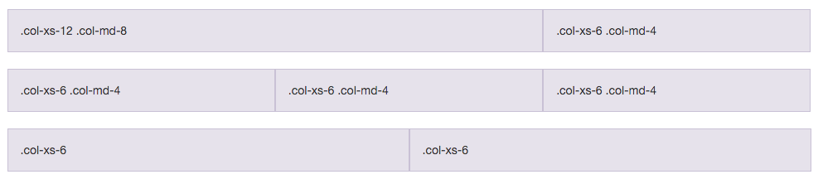

Let’s begin!

## Building a Basic Template with Bootstrap

Bootstrap comes with [a few very simple examples](https://getbootstrap.com/getting-started/#examples) to start from, but it’s just as easy to start from “scratch”, so that’s what we’ll do. First, I’ll use only Bootstrap to lay out the foundation, then we’ll add our own custom style on top to make something fun and trendy.

Step one is to [download Bootstrap](http://getbootstrap.com/getting-started/#download). The zip file will come with **css**, **fonts**, and **js** directories. Unzip that and save the files in some directory. Bootstrap doesn’t come with any HTML, but they have a “Hello, World!” page to start on the documentation, so we’ll use that as **index.html**.

**PHP Hypertext Preprocessor (PHP):** It is an open-source server-side scripting language designed for web development to produce dynamic web pages. It is one of the first developed server-side scripting languages to be embedded into an HTML source document rather than calling an external file to process data.

PHP (recursive acronym for PHP: Hypertext Preprocessor) is a widely-used open source general-purpose scripting language that is especially suited for web development and can be embedded into HTML.

Instead of lots of commands to output HTML (as seen in C or Perl), PHP pages contain HTML with embedded code that does "something" (in this case, output "Hi, I'm a PHP script!"). The PHP code is enclosed in special [start and end processing instructions <?php and ?>](http://php.net/manual/en/language.basic-syntax.phpmode.php) that allow you to jump into and out of "PHP mode."

What distinguishes PHP from something like client-side JavaScript is that the code is executed on the server, generating HTML which is then sent to the client. The client would receive the results of running that script, but would not know what the underlying code was. You can even configure your web server to process all your HTML files with PHP, and then there's really no way that users can tell what you have up your sleeve.

The best things in using PHP are that it is extremely simple for a newcomer, but offers many advanced features for a professional programmer. Don't be afraid reading the long list of PHP's features. You can jump in, in a short time, and start writing simple scripts in a few hours.

## PHP Features

There are given many features of PHP.

* **Performance**: Script written in PHP executes much faster then those scripts written in other languages such as JSP & ASP.
* **Open Source Software**: PHP source code is free available on the web, you can developed all the version of PHP according to your requirement without paying any cost.
* **Platform Independent**: PHP are available for WINDOWS, MAC, LINUX & UNIX operating system. A PHP application developed in one OS can be easily executed in other OS also.
* **Compatibility**: PHP is compatible with almost all local servers used today like Apache, IIS etc.
* **Embedded**: PHP code can be easily embedded within HTML tags and script.

# Configure PHP

To install PHP, we will suggest you to install AMP (Apache, MySQL, PHP) software stack. It is available for all operating systems. There are many AMP options available in the market that are given below:

* **WAMP** for Windows
* **LAMP** for Linux
* **MAMP** for Mac
* **SAMP** for Solaris
* **FAMP** for FreeBSD
* **XAMPP** (Cross, Apache, MySQL, PHP, Perl) for Cross Platform: It includes some other components too such as FileZilla, OpenSSL, Webalizer, OpenSSL, Mercury Mail etc.

If you are on Windows and don't want Perl and other features of XAMPP, you should go for WAMP. In a similar way, you may use LAMP for Linux and MAMP for Macintosh.

## Web Development using PHP

PHP is widely used in web development now a days. Dynamic websites can be easily developed by PHP. But you must have the basic the knowledge of following technologies for web development as well.

* HTML
* CSS
* JavaScript
* AJAX
* XML and JSON
* JQuery

**Cascading Style Sheets (CSS):** It is a style sheet language used for describing the presentation semantics (the look and formatting) of a document written in a markup language. Its most common application is to style web pages written in HTML and XHTML, but the language can also be applied to any kind of XML document, including plain XML, SVG and XUL. CSS is designed primarily to enable the separation of document content (written in HTML or a similar markup language) from document presentation, including elements such as the layout, colors, and fonts.

**C**ascading **S**tyle **S**heets, fondly referred to as CSS, is a simple design language intended to simplify the process of making web pages presentable.

CSS handles the look and feel part of a web page. Using CSS, you can control the color of the text, the style of fonts, the spacing between paragraphs, how columns are sized and laid out, what background images or colors are used, layout designs,variations in display for different devices and screen sizes as well as a variety of other effects.

CSS is easy to learn and understand but it provides powerful control over the presentation of an HTML document. Most commonly, CSS is combined with the markup languages HTML or XHTML.

## Advantages of CSS

* **CSS saves time** − You can write CSS once and then reuse same sheet in multiple HTML pages. You can define a style for each HTML element and apply it to as many Web pages as you want.
* **Pages load faster** − If you are using CSS, you do not need to write HTML tag attributes every time. Just write one CSS rule of a tag and apply it to all the occurrences of that tag. So less code means faster download times.
* **Easy maintenance** − To make a global change, simply change the style, and all elements in all the web pages will be updated automatically.
* **Superior styles to HTML** − CSS has a much wider array of attributes than HTML, so you can give a far better look to your HTML page in comparison to HTML attributes.
* **Multiple Device Compatibility** − Style sheets allow content to be optimized for more than one type of device. By using the same HTML document, different versions of a website can be presented for handheld devices such as PDAs and cell phones or for printing.
* **Global web standards** − Now HTML attributes are being deprecated and it is being recommended to use CSS. So its a good idea to start using CSS in all the HTML pages to make them compatible to future browsers.
* **Offline Browsing** − CSS can store web applications locally with the help of an offline catche.Using of this, we can view offline websites.The cache also ensures faster loading and better overall performance of the website.
* **Platform Independence** − The Script offer consistent platform independence and can support latest browsers as well.

## Who Creates and Maintains CSS?

CSS was invited by **Håkon Wium Lie** on October 10, 1994 and maintained through a group of people within the W3C called the CSS Working Group. The CSS Working Group creates documents called **specifications**. When a specification has been discussed and officially ratified by W3C members, it becomes a recommendation.

These ratified specifications are called recommendations because the W3C has no control over the actual implementation of the language. Independent companies and organizations create that software.

**NOTE** − The World Wide Web Consortium, or W3C is a group that makes recommendations about how the Internet works and how it should evolve.

**CSS Versions**

Cascading Style Sheets, level 1 (CSS1) was came out of W3C as a recommendation in December 1996. This version describes the CSS language as well as a simple visual formatting model for all the HTML tags.

CSS2 was became a W3C recommendation in May 1998 and builds on CSS1. This version adds support for media-specific style sheets e.g. printers and aural devices, downloadable fonts, element positioning and tables.

CSS3 was became a W3C recommendation in June 1999 and builds on older versions CSS. it has divided into documentations is called as Modules and here each module having new extension features defined in CSS2.

### CSS3 Modules

CSS3 Modules are having old CSS specifications as well as extension features.

* Selectors
* Box Model
* Backgrounds and Borders
* Image Values and Replaced Content
* Text Effects
* 2D/3D Transformations
* Animations
* Multiple Column Layout
* User Interface

A CSS comprises of style rules that are interpreted by the browser and then applied to the corresponding elements in your document. A style rule is made of three parts −

* **Selector** − A selector is an HTML tag at which a style will be applied. This could be any tag like <h1> or <table> etc.
* **Property** - A property is a type of attribute of HTML tag. Put simply, all the HTML attributes are converted into CSS properties. They could be *color*, *border* etc.
* **Value** - Values are assigned to properties. For example, *color* property can have value either *red* or *#F1F1F1* etc

Before CSS, nearly all presentational attributes of HTML documents were contained within the HTML markup. All font colors, background styles, element alignments, borders and sizes had to be explicitly described, often repeatedly, within the HTML. CSS lets authors move much of that information to another file, the style sheet, resulting in considerably simpler HTML.

For example, headings (h1 elements), sub-headings (h2), sub-sub-headings (h3), etc., are defined structurally using HTML. In print and on the screen, choice of [font](https://en.wikipedia.org/wiki/Typeface), [size](https://en.wikipedia.org/wiki/Point_%28typography%29), [color](https://en.wikipedia.org/wiki/Color) and [emphasis](https://en.wikipedia.org/wiki/Emphasis_%28typography%29) for these elements is *presentational*.

Before CSS, document authors who wanted to assign such [typographic](https://en.wikipedia.org/wiki/Typography) characteristics to, say, all h2 headings had to repeat HTML presentational markup for each occurrence of that heading type. This made documents more complex, larger, and more error-prone and difficult to maintain. CSS allows the separation of presentation from structure. CSS can define color, font, text alignment, size, borders, spacing, layout and many other typographic characteristics, and can do so independently for on-screen and printed views. CSS also defines non-visual styles, such as reading speed and emphasis for aural text readers. The [W3C](https://en.wikipedia.org/wiki/W3C) has now [deprecated](https://en.wikipedia.org/wiki/Deprecation) the use of all presentational HTML markup.

. CSS information can be provided from various sources. These sources can be the web browser, the user and the author. The information from the author can be further classified into inline, media type, importance, selector specificity, rule order, inheritance and property definition. CSS style information can be in a separate document or it can be embedded into an HTML document. Multiple style sheets can be imported. Different styles can be applied depending on the output device being used; for example, the screen version can be quite different from the printed version, so that authors can tailor the presentation appropriately for each medium.

The style sheet with the highest priority controls the content display. Declarations not set in the highest priority source are passed on to a source of lower priority, such as the user agent style. This process is called *cascading*.

One of the goals of CSS is to allow users greater control over presentation. Someone who finds red italic headings difficult to read may apply a different style sheet. Depending on the browser and the web site, a user may choose from various style sheets provided by the designers, or may remove all added styles and view the site using the browser's default styling, or may override just the red italic heading style without altering other attributes

## CSS frameworks

[CSS frameworks](https://en.wikipedia.org/wiki/CSS_framework) are pre-prepared [libraries](https://en.wikipedia.org/wiki/Library_%28computing%29) that are meant to allow for easier, more [standards-compliant](https://en.wikipedia.org/wiki/Standards-compliant) styling of [web pages](https://en.wikipedia.org/wiki/Web_page) using the Cascading Style Sheets language. CSS frameworks include [Foundation](https://en.wikipedia.org/wiki/Foundation_%28framework%29), [Blueprint](https://en.wikipedia.org/wiki/Blueprint_%28CSS_framework%29), [Bootstrap](https://en.wikipedia.org/wiki/Bootstrap_%28framework%29), [Cascade Framework](https://en.wikipedia.org/wiki/Cascade_Framework) and Materialize. Like programming and scripting language libraries, CSS frameworks are usually incorporated as external .css sheets referenced in the HTML <head>. They provide a number of ready-made options for designing and laying out the web page. Although many of these frameworks have been published, some authors use them mostly for rapid prototyping, or for learning from, and prefer to 'handcraft' CSS that is appropriate to each published site without the design, maintenance and download overhead of having many unused features in the site's styling.

**HyperText Markup Language** (**HTML**): It is the main markup language for creating web pages and other information that can be displayed in a web browser. HTML is written in the form of HTML elements consisting of *tags* enclosed in angle brackets, within the web page content. The first tag in a pair is the *start tag*, the second tag is the *end tag* .

HTML is a computer language devised to allow website creation. These websites can then be viewed by anyone else connected to the Internet. It is relatively **easy to learn**, with the basics being accessible to most people in one sitting; and quite **powerful** in what it allows you to create. It is constantly undergoing revision and evolution to meet the demands and requirements of the growing Internet audience under the direction of the [» W3C](http://www.w3.org/), the organisation charged with designing and maintaining the language.

The definition of HTML is **HyperText Markup Language**.

* HyperText is the method by which you move around on the web — by clicking on special text called **hyperlinks** which bring you to the next page. The fact that it is hyper just means it is not linear — i.e. you can go to any place on the Internet whenever you want by clicking on links — there is no set order to do things in.
* Markup is what **HTML tags** do to the text inside them. They mark it as a certain type of text (italicised text, for example).
* HTML is a Language, as it has code-words and syntax like any other language.

### How does it work?

HTML consists of a series of short **codes** typed into a text-file by the site author — these are the tags. The text is then **saved as a html file**, and **viewed through a** [**browser**](http://www.yourhtmlsource.com/starthere/glossary.html#browser), like Internet Explorer or Netscape Navigator. This browser reads the file and translates the text into a visible form, hopefully rendering the page as the author had intended. Writing your own HTML entails using tags correctly to create your vision. You can use anything from a rudimentary text-editor to a powerful graphical editor to create HTML pages.

### What are the tags up to?

The tags are what separate normal text from HTML code. You might know them as the words between the <angle-brackets>. They allow all the cool stuff like images and tables and stuff, just by telling your browser what to render on the page. Different tags will perform different functions. The tags themselves don’t appear when you view your page through a browser, but their effects do. The simplest tags do nothing more than apply formatting to some text, like this:

**<b>**These words will be bold**</b>**, and these will not.

In the example above, the <b> tags were wrapped around some text, and their effect will be that the contained text will be bolded when viewed through an ordinary web browser.

If you want to see a list of a load of tags to see what’s ahead of you, look at [this tag reference](http://www.yourhtmlsource.com/myfirstsite/tagreference.html). Learning the tags themselves is dealt with in the next section of this website, [My First Site](http://www.yourhtmlsource.com/myfirstsite/).

[**Cascading Style sheets**](http://www.yourhtmlsource.com/stylesheets/) are used to control how your pages are presented, and make pages more accessible. Basic special effects and interaction is provided by [**JavaScript**](http://www.yourhtmlsource.com/javascript/), which adds a lot of power to basic HTML. Most of this advanced stuff is for later down the road, but when using all of these technologies together, you have a lot of power at your disposal.

**Selenium Web Driver For Testing**

**Web Driver** is a tool for automating web application testing, and in particular to verify that they work as expected. It aims to provide a friendly API that's easy to explore and understand, easier to use than the **Selenium**-RC (1.0) API, which will help to make your tests easier to read and maintain.

**Step1:Install Java on your computer.**   
  
Download and install the Java Software Development Kit (JDK). You download the JDK file from this location:<http://www.oracle.com/technetwork/java/javase/downloads/index.html>

**Step2:Install Eclipses IDE**  
  
Now download “Eclipse IDE for Java Developers”. You can download eclipses from this location: <http://www.eclipse.org/downloads/>

**Step 3 – Download the Selenium Java Client Driver**  
  
You can download the Selenium Java Client Driver from this location:<http://docs.seleniumhq.org/download/>

**2.2 Hardware Requirement**

Application architecture –**AJAX, PHP, HTML, CSS, JavaScript and jQuery**

Web server – **WampServer (any with PHP support)**

Database platform –**MySQL**

Development and design tool – **Sublime.**

can be extended by users with plug-ins, typically community built and maintained under free software licenses.

To install PHP, we will suggest you to install AMP (Apache, MySQL, PHP) software stack. It is available for all operating systems. There are many AMP options available in the market that are given below:

* **WAMP** for Windows
* **LAMP** for Linux
* **MAMP** for Mac
* **SAMP** for Solaris
* **FAMP** for FreeBSD
* **XAMPP** (Cross, Apache, MySQL, PHP, Perl) for Cross Platform: It includes some other components too such as FileZilla, OpenSSL, Webalizer, OpenSSL, Mercury Mail etc.

If you are on Windows and don't want Perl and other features of XAMPP, you should go for WAMP. In a similar way, you may use LAMP for Linux and MAMP for Macintosh.



**3 PROJECT PLANNING**

The most important and critical phase of managing system projects is planning. Information systems have become increasingly important during the past decade. Information is now recognized as a vital resource. And there is growing need for formal long-range planning with Information systems.

**3.1 Project Scope**

The scope of the project can be described in the following manner:

* Software can deal with an operator or an admin.
* It can be used by any IIPS Teachers who have a valid ID.
* Report will be generated according to the format of UTD’s self appraisal form.

**3.2 Documentation Plan**

Documentation plan will be as listed below:-

* IEEE standard will be followed for all documentation purpose.
* All documents would be discussed with the project in-charge.
* All documents will be reviewed with the project in-charge.
* All documents will be available in soft copy and hard copy.
* All documents would be submitted on mentioned date of schedule.

**3.3 Team Structure**

Team Structure involves:-

* Team involves software developer

Ritika Barethia

Shubham Neema

Sweta Rathore

Vikas Chouhan.

**3.4 Gantt Chart**

Gantt chart is a time-phased bar chart display that lists tasks or activities along the left side and a corresponding bar for each task. The length of the bar represents the duration of the activity. This scheduling tool used to display the status of a project’s tasks. The Gantt chart shows each task’s duration as a horizontal line. The ends of the lines correspond to the task’s start and end dates.

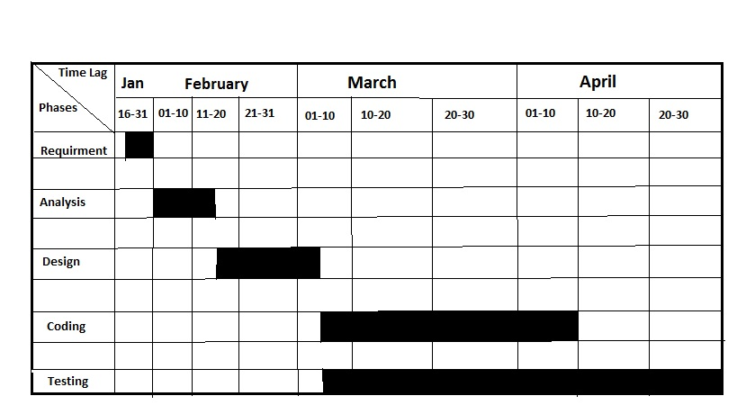

**4. CURRENT SYSTEM AND PROPOSED SYSTEM**

**CURRENT AND PROPOSED SYSTEM**



**4.1 Current System**

The current system used by the user involves entry of each user’s information in a register or a doc file. Admin needs to find each record at a regular interval of time in order to assess the users performance based on two months, three months and to manage information of all the users. Thus all the information are on paper. The searching of desired information takes a lot of time and effort. There exist no backup of the prepared report.

**4.2 Limitations of Current System**

The current system has a large number of limitations. These limitations encourage the improper maintenance of Information. At the time of requirement gathering and analysis, the following limitations are discovered.

.

* Since the system is manual there is scope of error due to carelessness and manipulation.
* No backups of the records are maintained due to the tedious nature of the work.
* Searching for particular records gets more and more difficult as the records get older.
* Report is prepared at the regular interval so there is a possibility that some information may get left.
* The manual system is not consistent in nature.
* Important reports cannot be generated on time due to cumbersome nature of task.
* Since there is a lot of repetition of information, which has to be done manually, there is no check for wrong replication of records.
* No recovery of data is possible by any means if it gets lost.

**4.3 Proposed System**

The following points gives an overview of the proposed system :

* The proposed system is a completely automated system, which manages the entire information of an individual.
* The system also generates appropriate reports.
* The proposed system helps the user to retrieve the information as quickly as possible.
* The system provides backup plans to avoid data loss that is of high priority.
* The system provides a user-friendly interface with a realistic view.
* The system provides an error free environment.
* The system is capable enough to reduce the number of register.

**4.4 Objectives of Proposed System**

Following are the objectives of the proposed system:-

* The objectives of the proposed system are to remove the limitations of the current system.
* To reduce data duplication.
* Implement validation techniques and checks that will help reduce the margin of error in operations.
* The system ensures consistency.

**5. FEASIBILITY STUDY**

**FEASIBILITY STUDY** 



Feasibility Study is the step to determine exactly what the candidate system is to do by defining its expected performance. This step involves selecting of the best candidate system among the alternatives such that it should be feasible or beneficial in terms of Economical, Technical and behavioral considerations of feasibility study

**5.1 Economic Feasibility**

Economic analysis is the most frequently used method for evaluating the cost effectiveness of the system. It is more commonly known as cost/benefit analysis.

The FPBAS is tested for economic feasibility and is completely feasible economically. Following table justify the economic feasibility of FPBAS.

|  |  |  |
| --- | --- | --- |
| **S. No.** | **Points of consideration** | **Justification** |
| 1 | Computer System for development process | Available in the lab of the institute |
| 2 | Electricity cost | Available in the institute |
| 3 | Internet connection | Available in the institute |
| 4 | Cost of the front-end and back-end tool used | Available for free of cost |
| 5 | Cost for the preparation of documents | Nominal |
| 6 | Complete cost of software for selling (Selling Price) | Easily affordable |

**5.2 Technical Feasibility**

The FPBAS is technically feasible considering the following criteria:-

* EASE OF USE: User can operate the system easily who have the basic knowledge of operating a computer.
* SECURITY : The data of the individual is secure and well protected
* O.S COMPATIBILITY: It can be operated in a windows based system which is available at client’s sight.
* HARDWARE COMPATIBILITY: It requires very nominal storage as the information will be in the form of plain text.
* MAINTAINABILITY: The system being developed is made general purpose with respect to user’s requirement hence there will be less maintenance .

**5.3 Behavioral Feasibility**

Behavioral feasibility is an important consideration in feasibility study. Being an application for a general user PBAS is a feasible in terms of behavioral feasibility. Following points justify the behavioral feasibility of PBAS:-

* Easy to operate.
* Convenient in maintenance.
* Effective in its function.
* Retrieval of information is according to user’s requirement.
* Retrieval of information is easy, fast and accurate than the previous system.
* Help is provided for the easy understanding of the functions of FPBAS.

**6.ANALYSIS**

**ANALYSIS**

**6.1 Form**

The following Interview questions were taken for further analysis :- 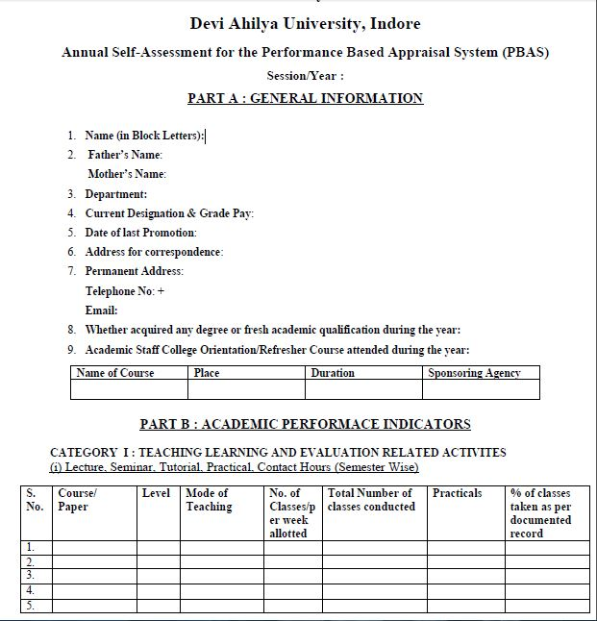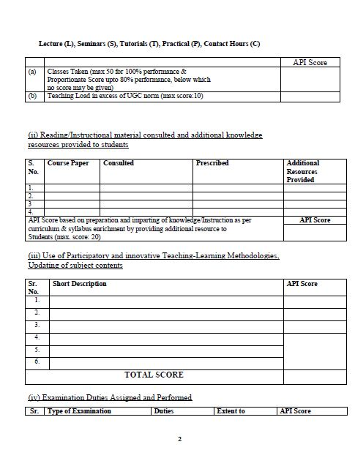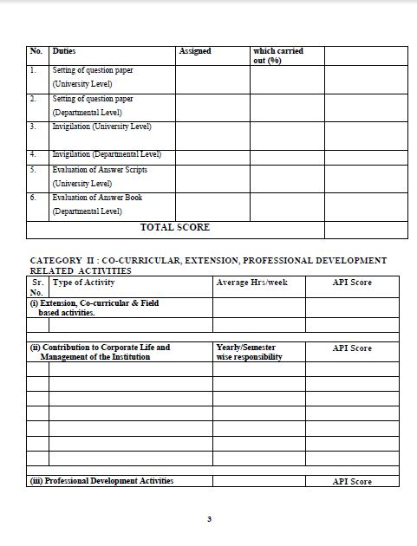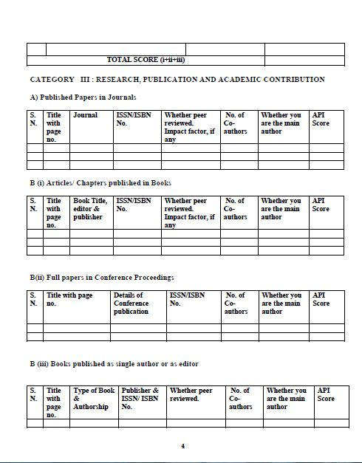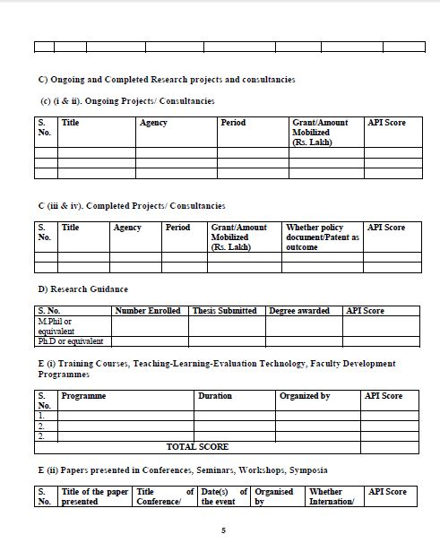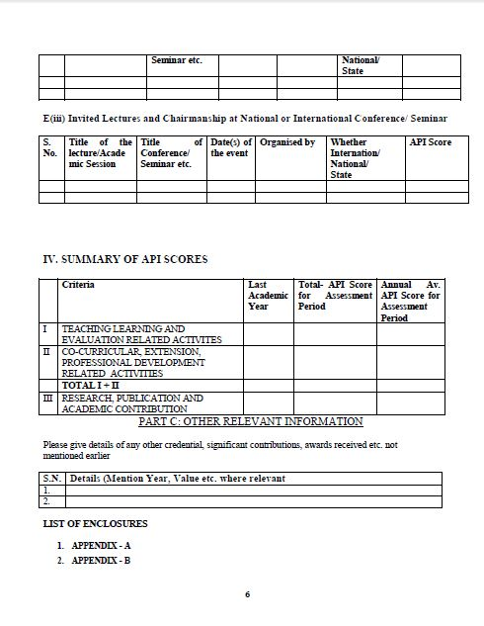

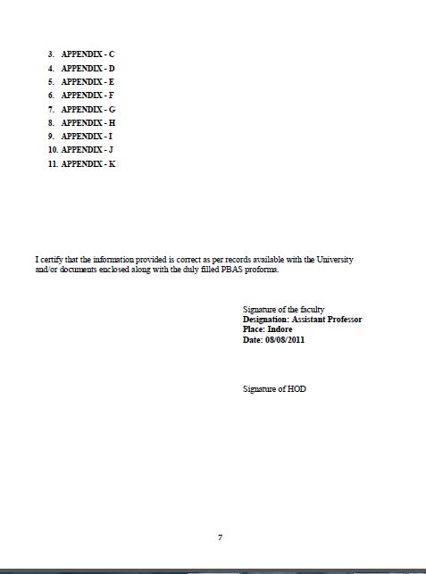

**7 DESIGN**



**7.1 Logical Design**

**Usecase Diagrams**

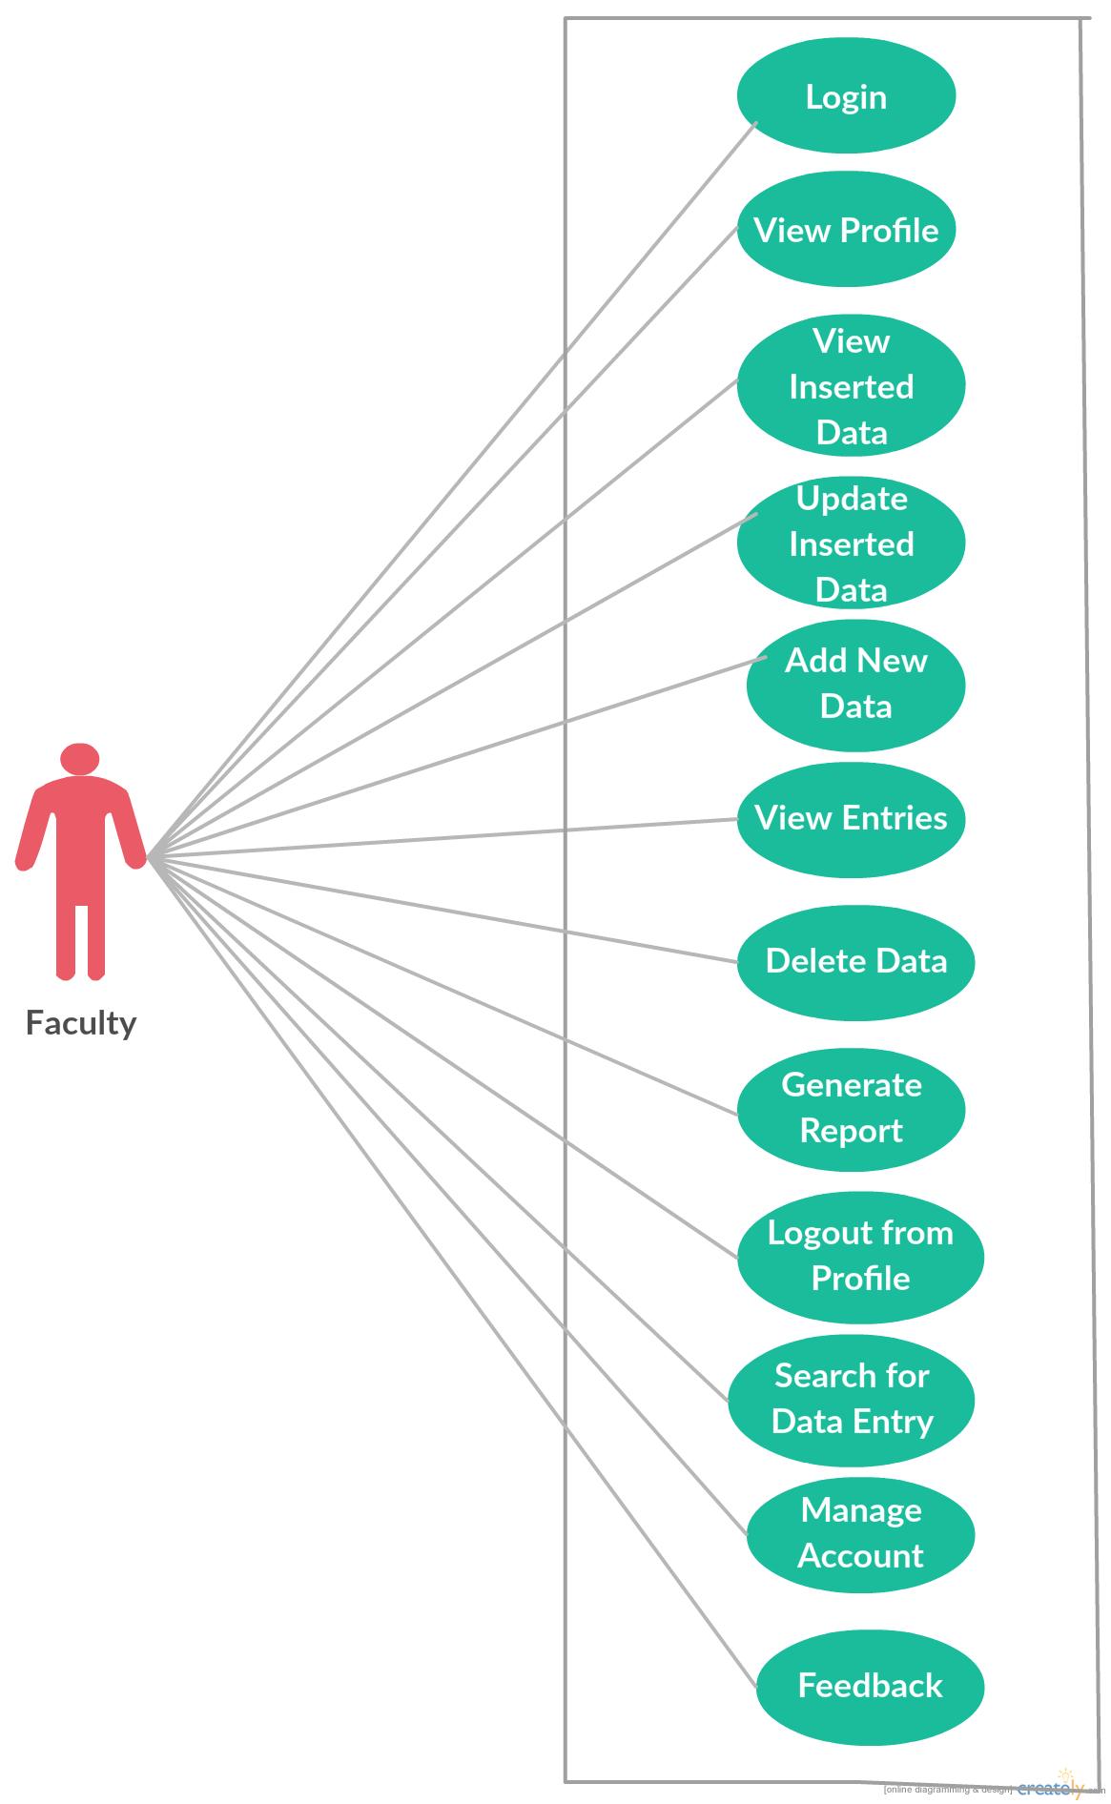

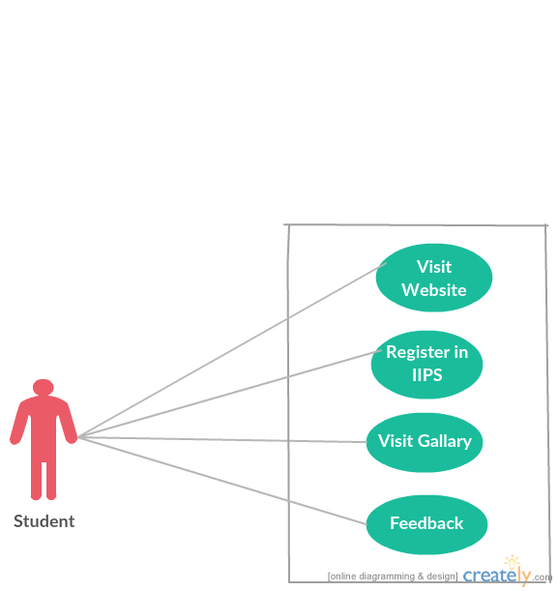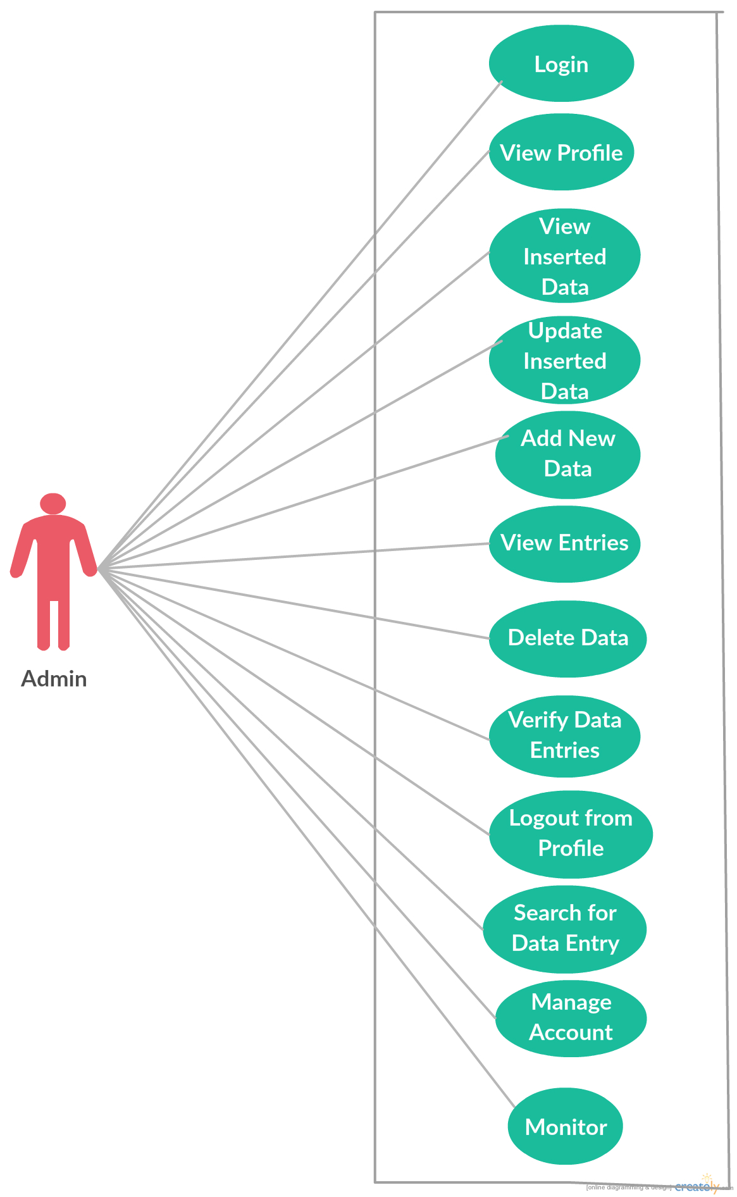

**Login flow chart**

**Faculty login**

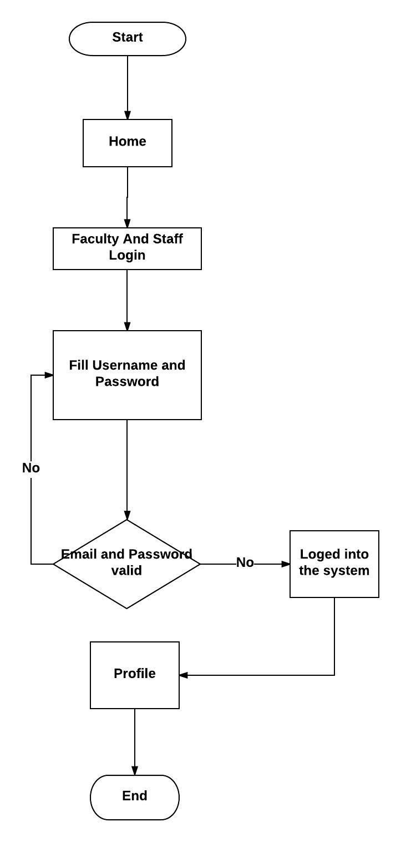

**Add/ Remove/Update Data**

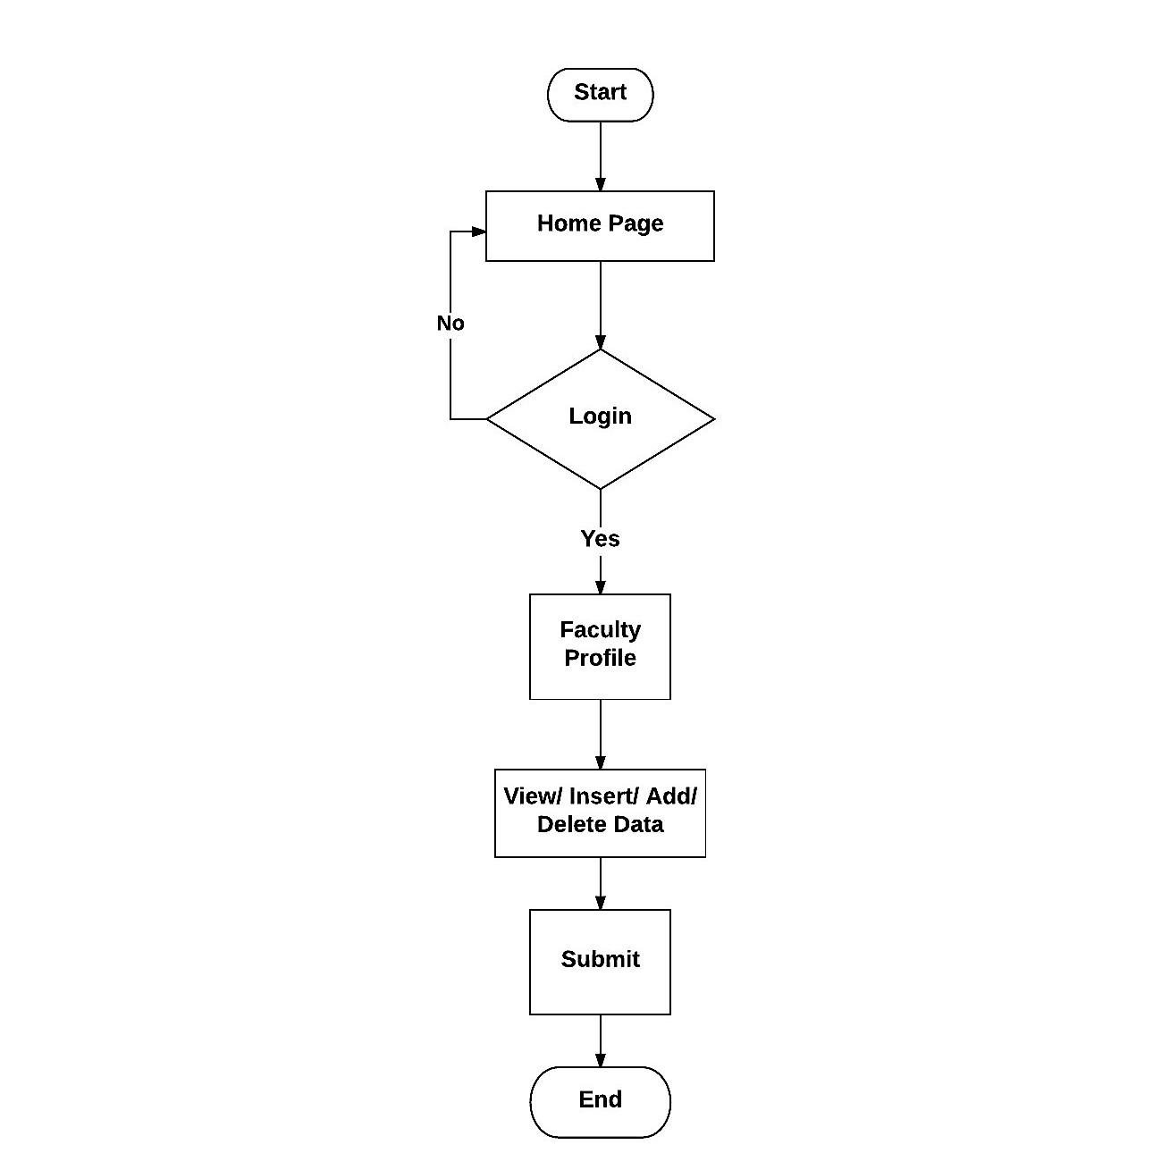

**View Profile**

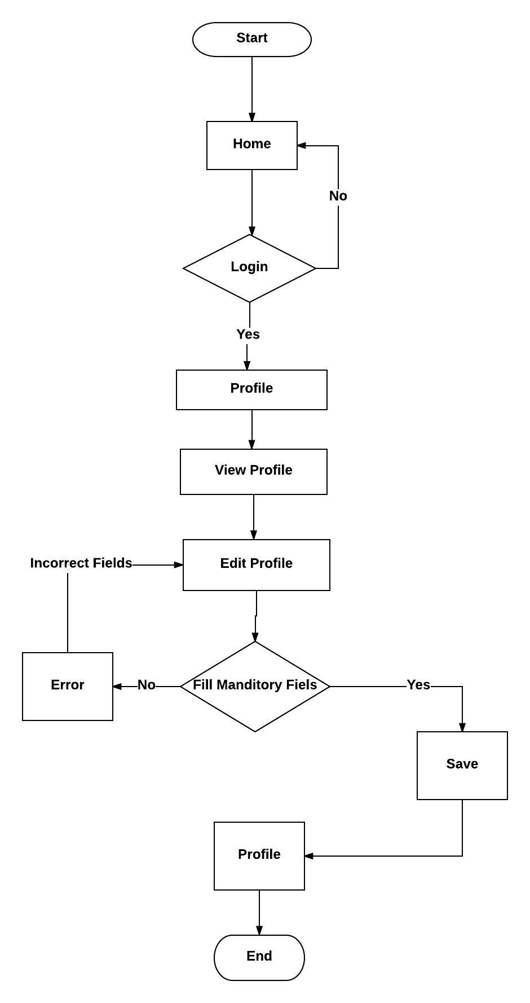

**Research_And_Co-Curricular**

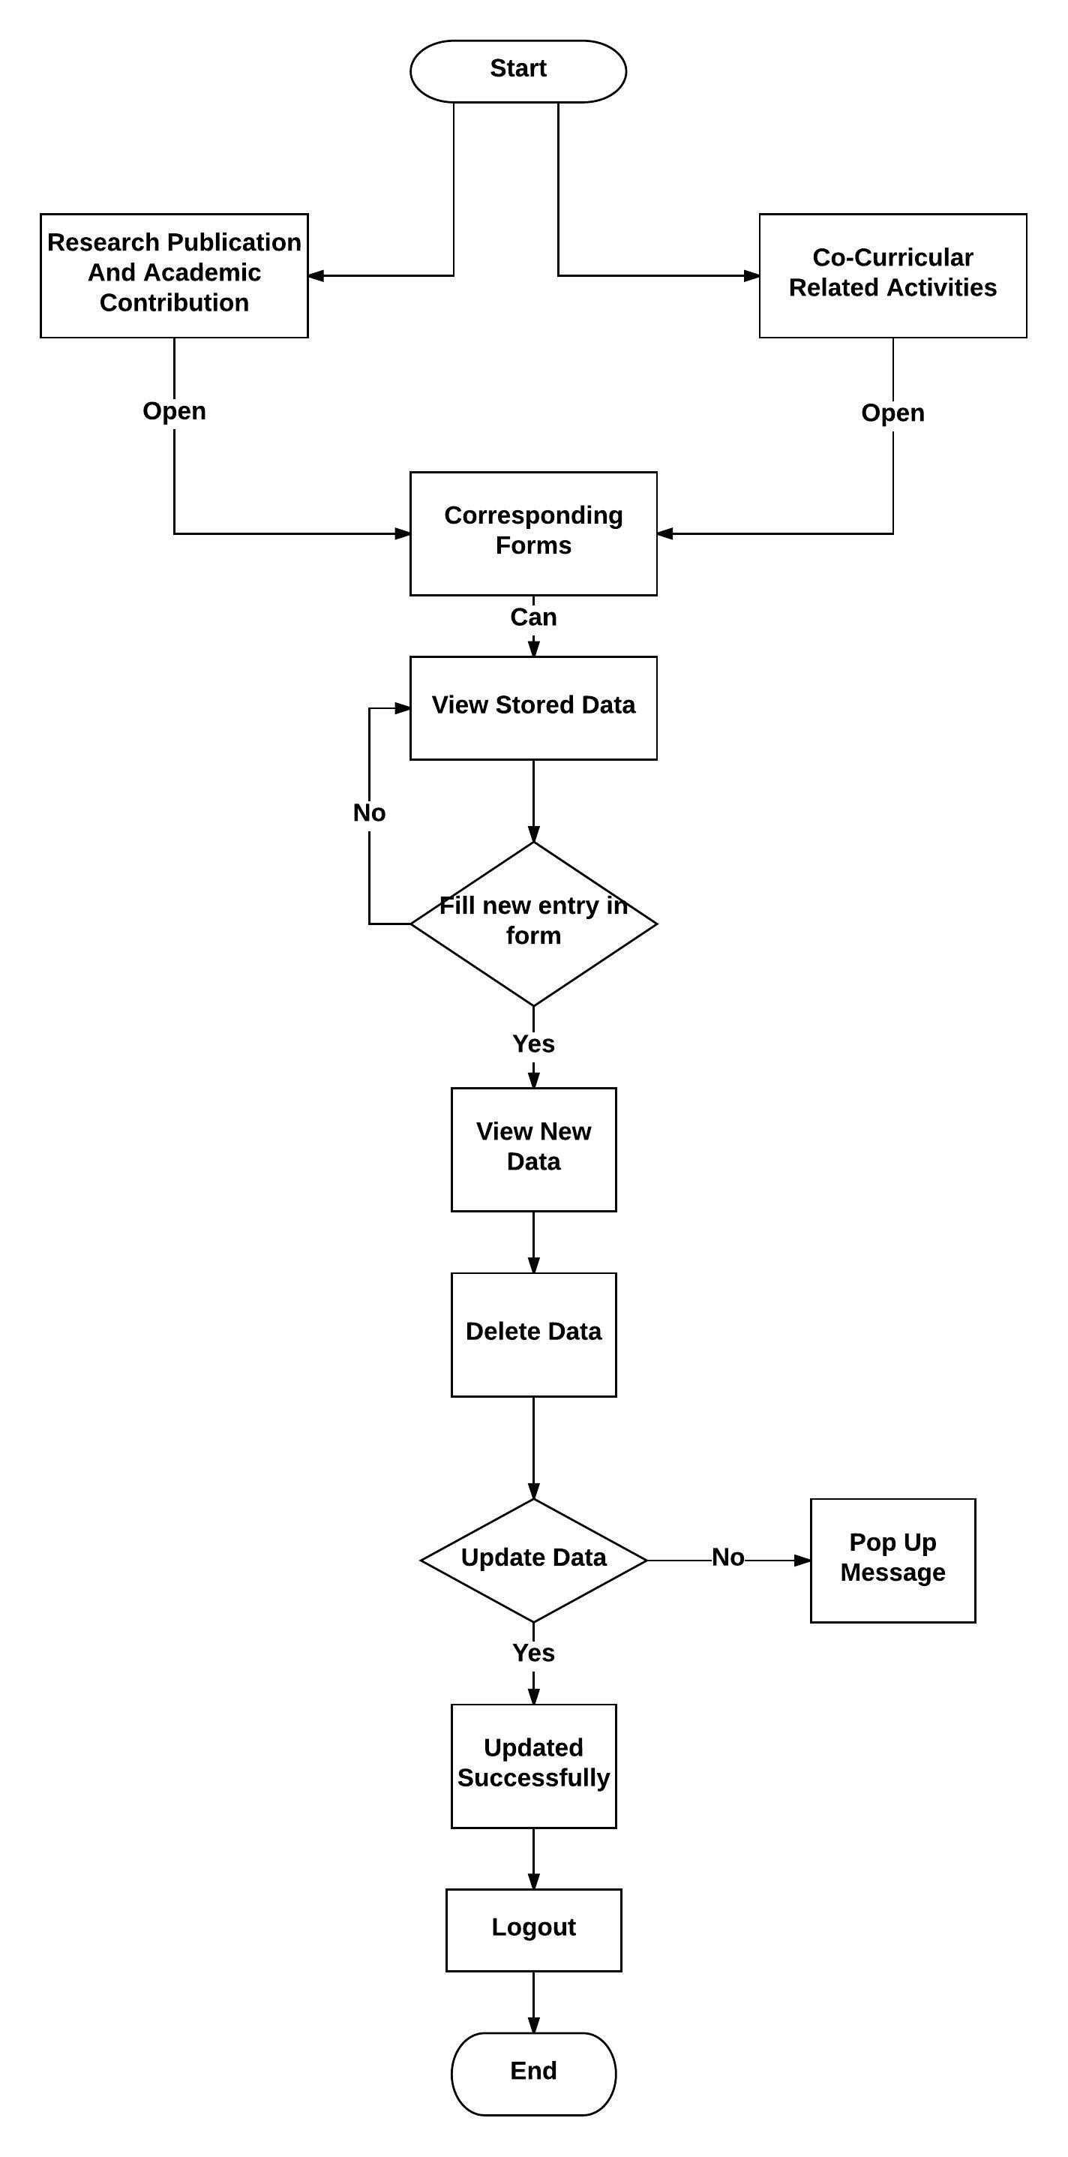

**Data Flow Diagram**

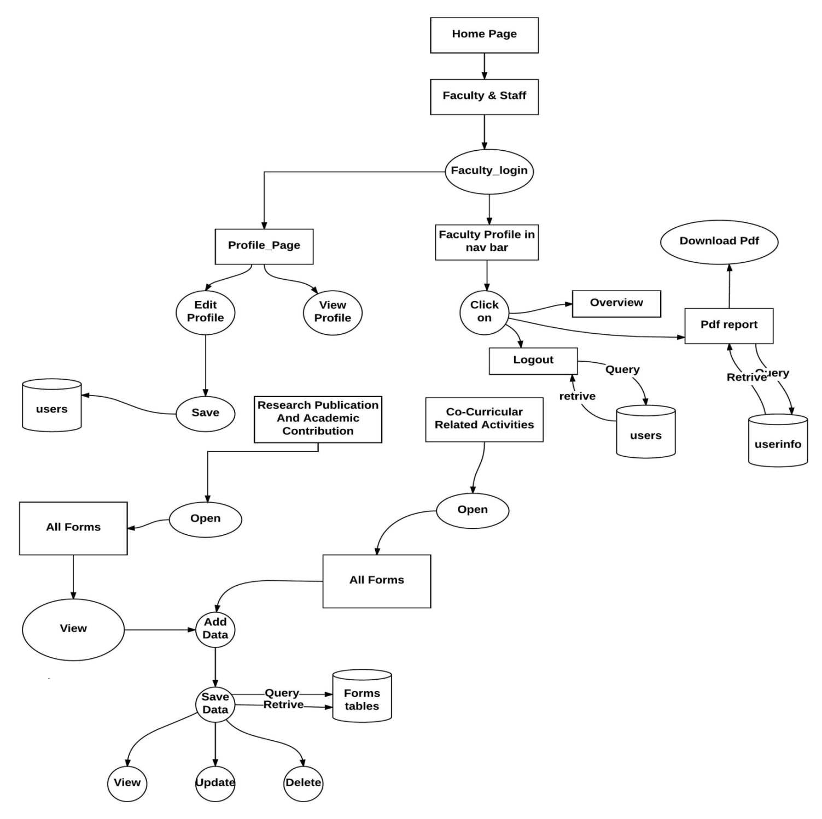

**Activity Diagram**

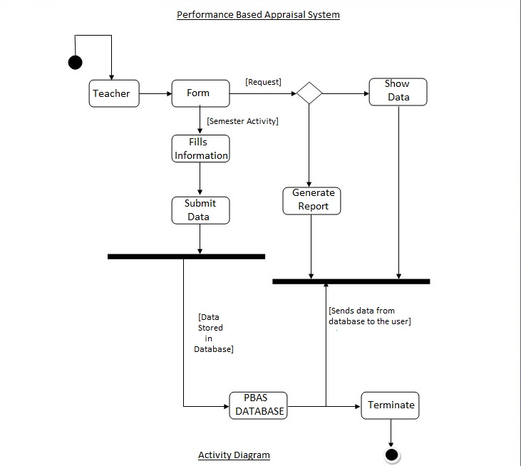

**ER Diagram**

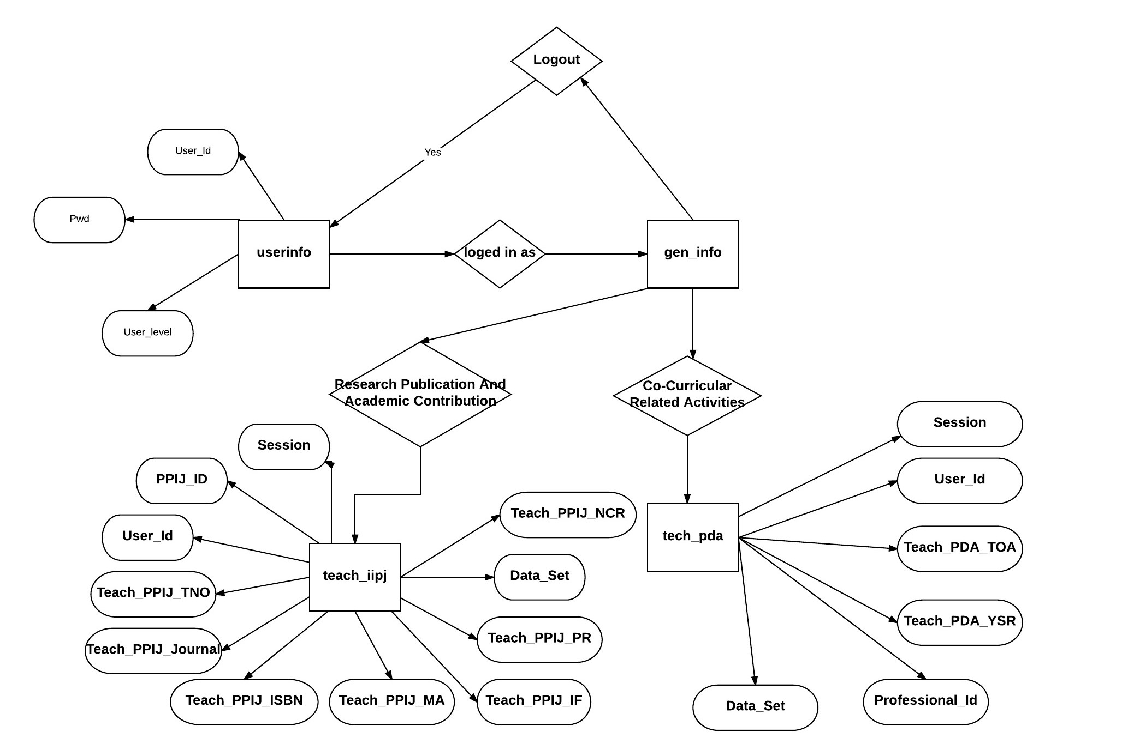

**System diagram**

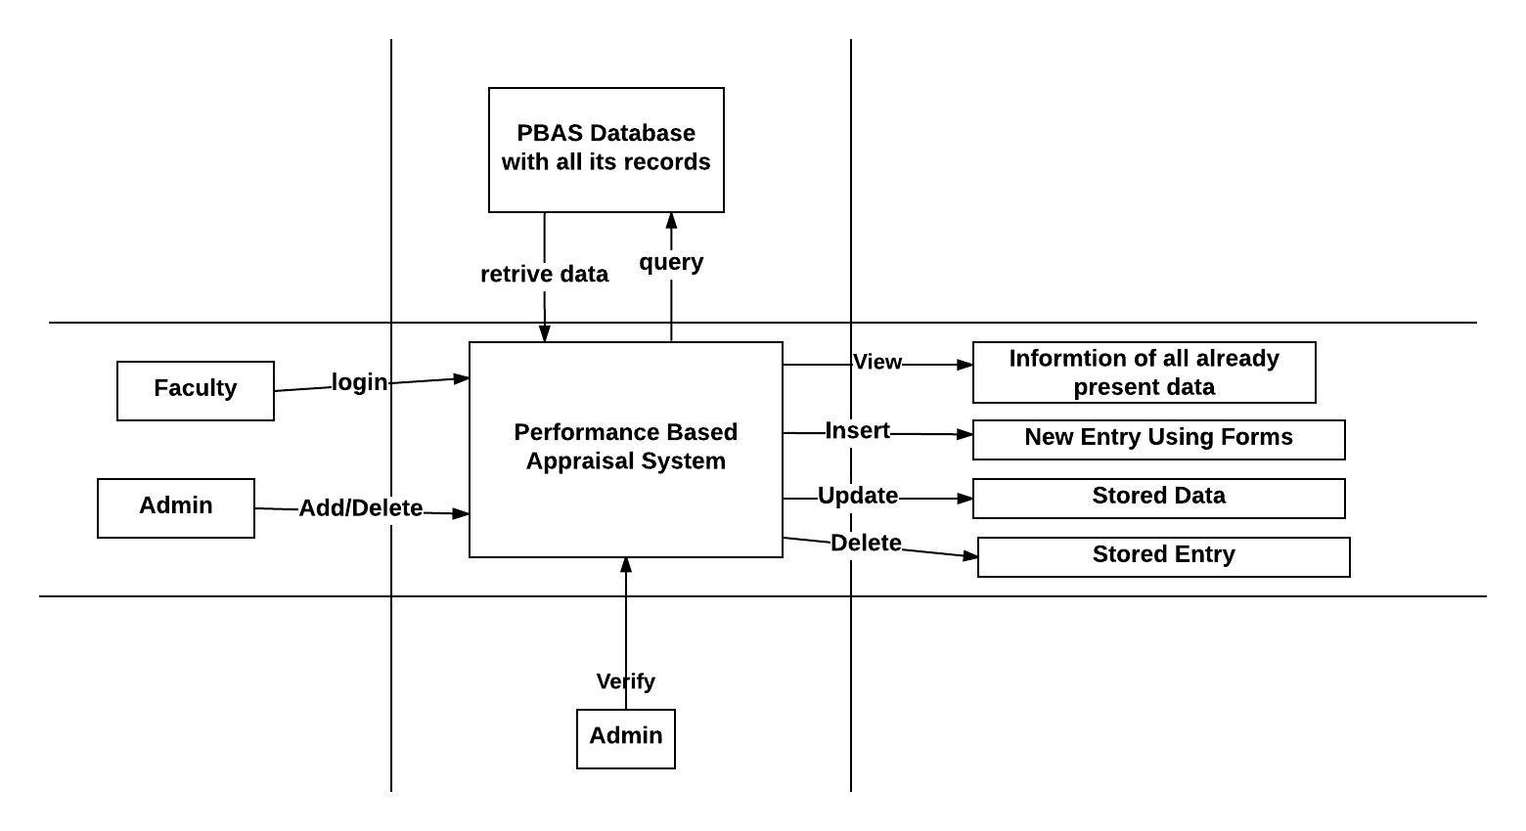

**Class Diagram**

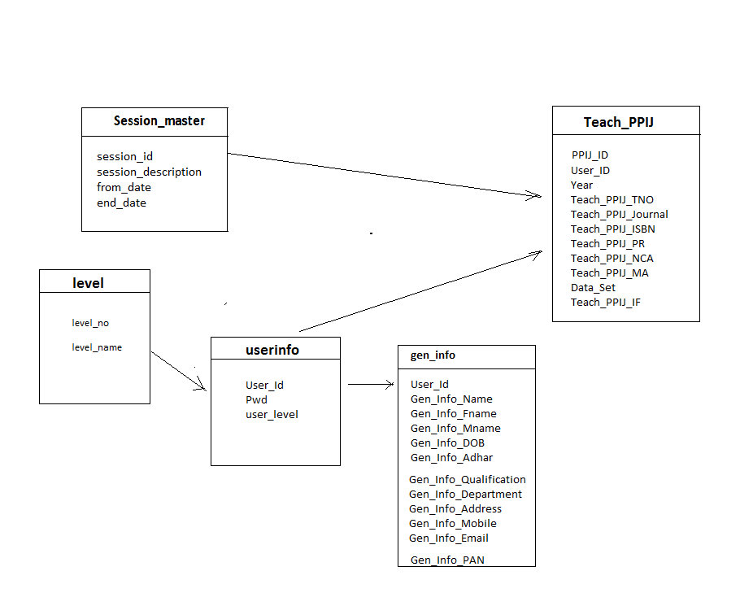

**6.2 Physical Design**

**Wire frame Diagram**

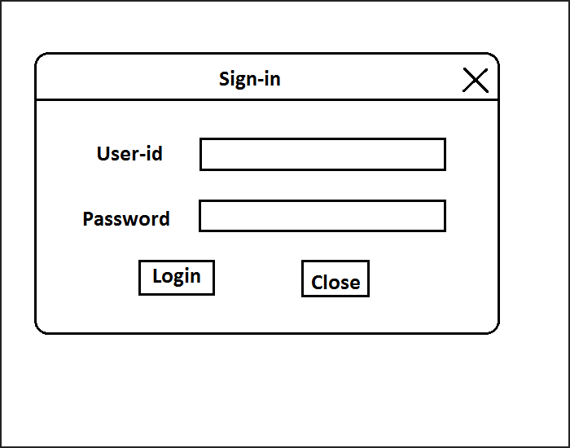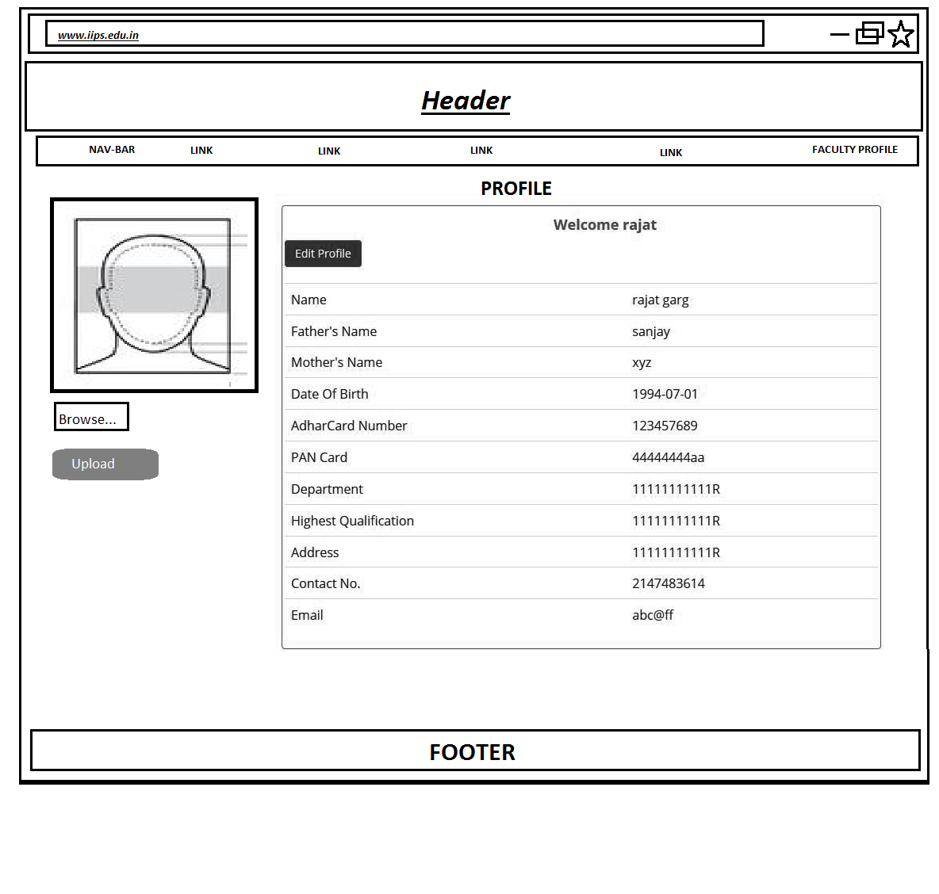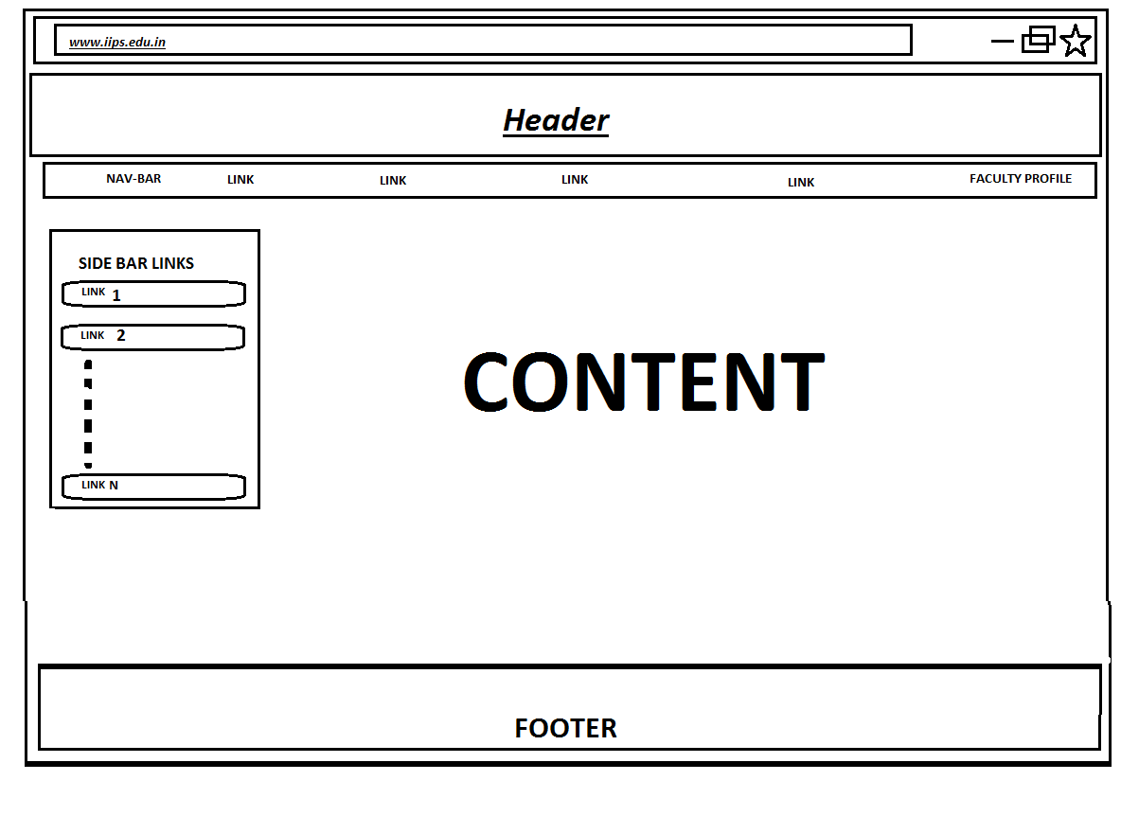

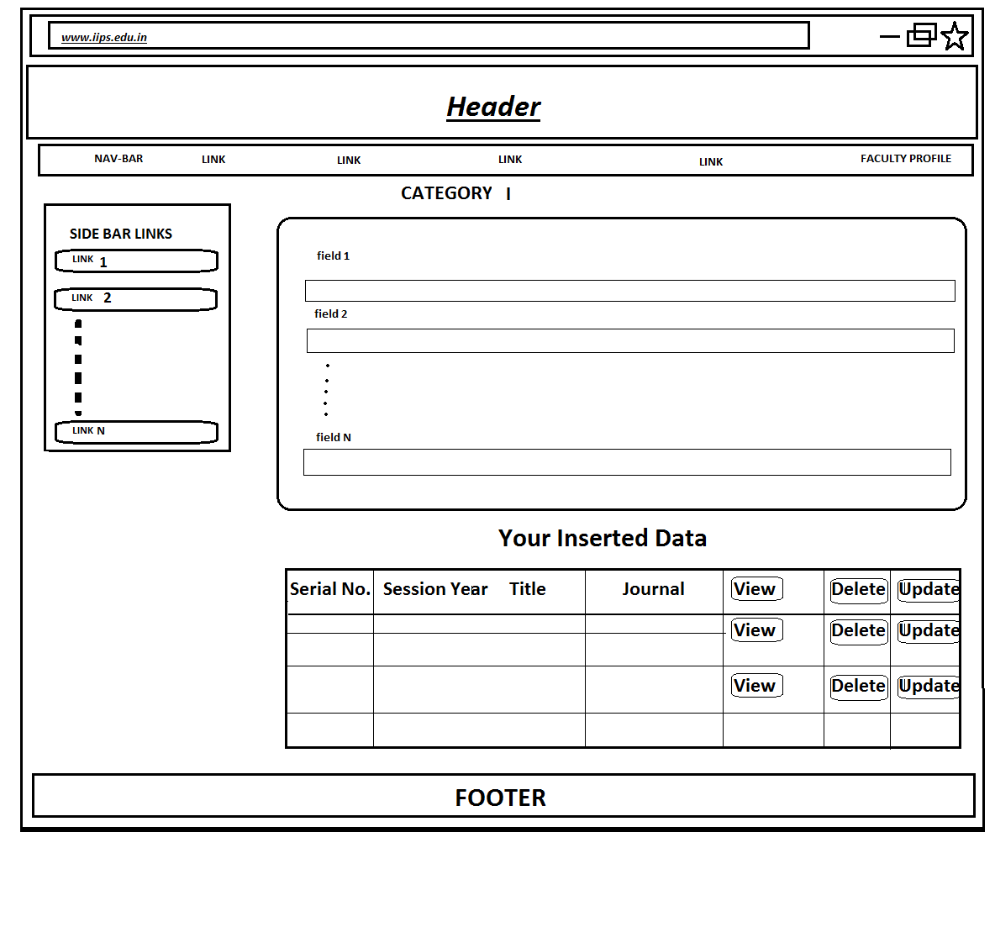

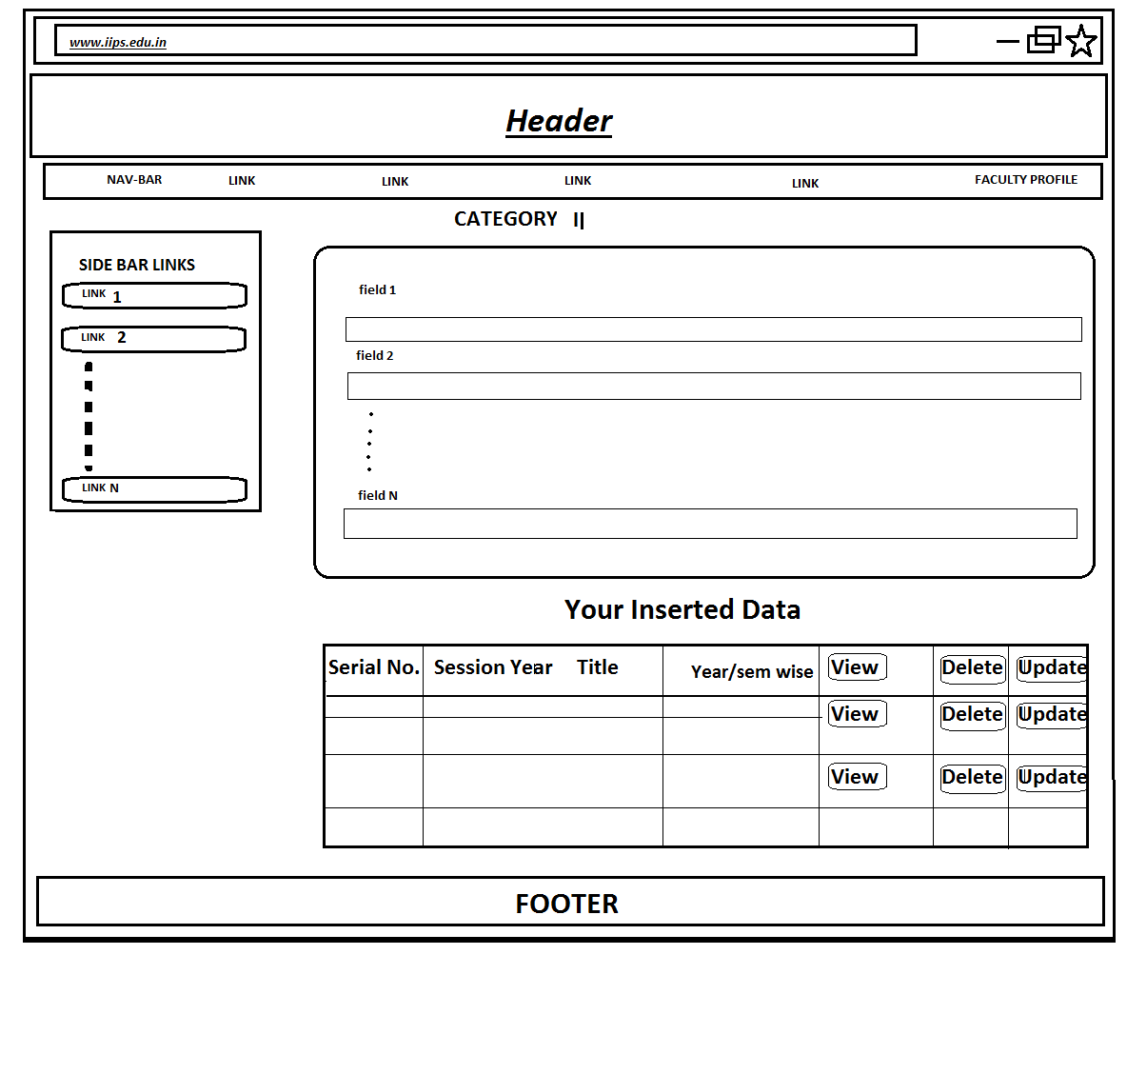



**Database Structure**

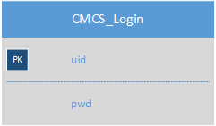

**7.3 User Interface**

**IIPS Website**

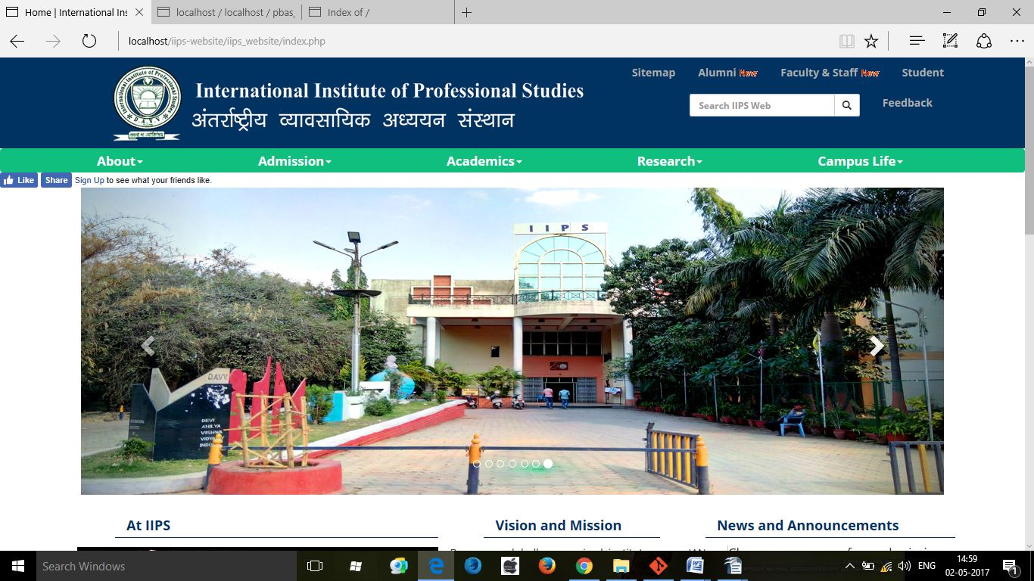

**Login**

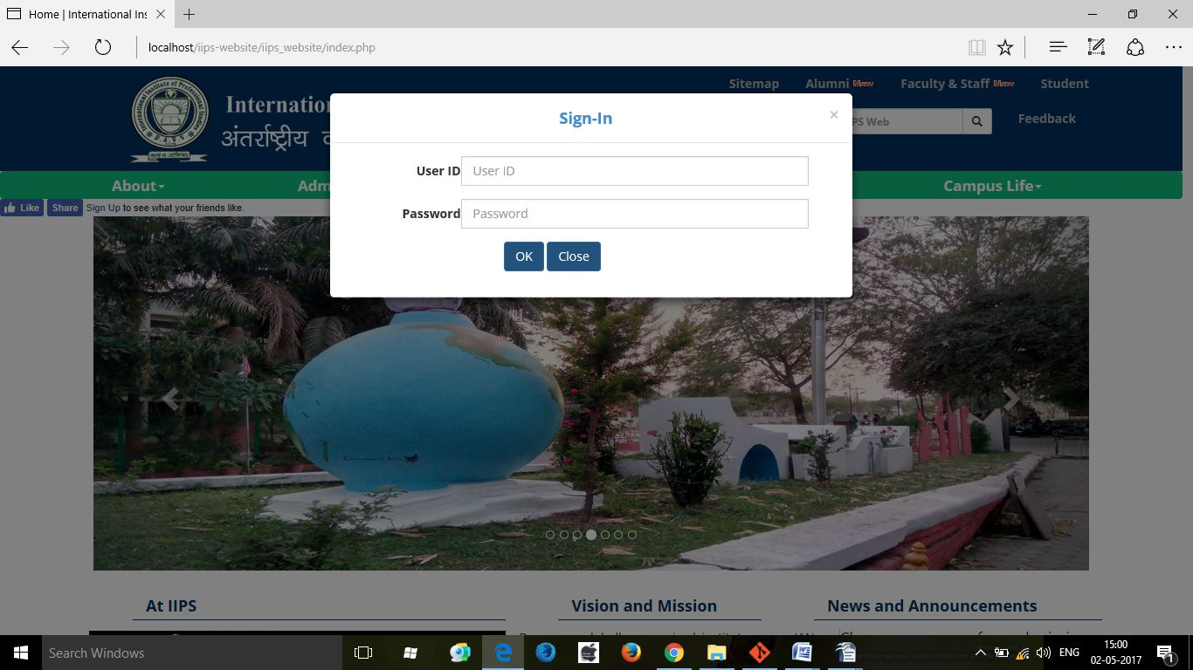

**Profile**

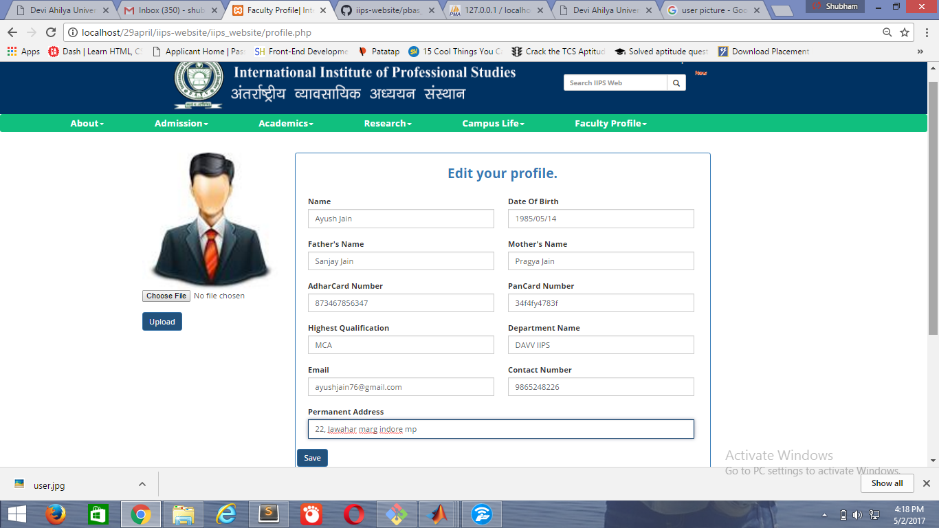

**Form**

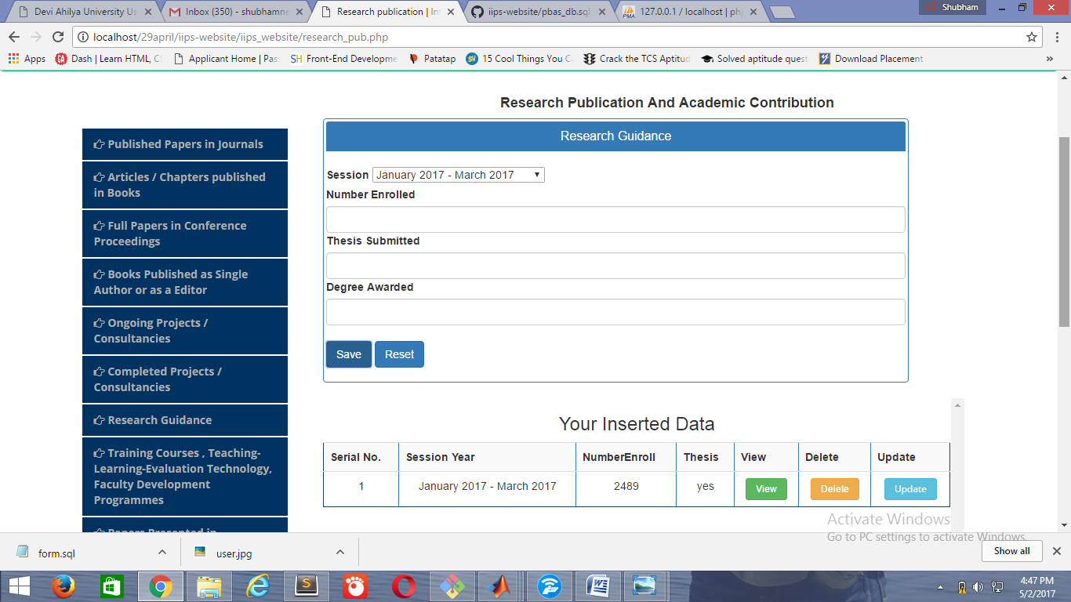

**View model**

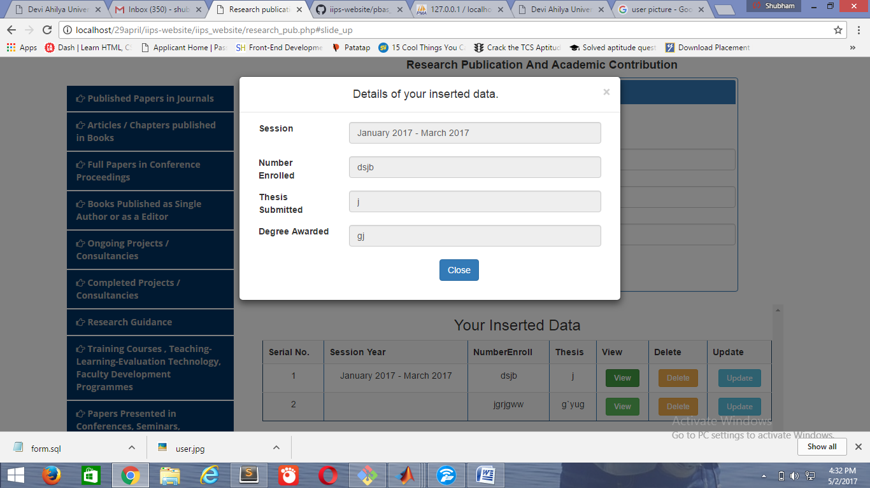

**Alumni registration**



**Contact**

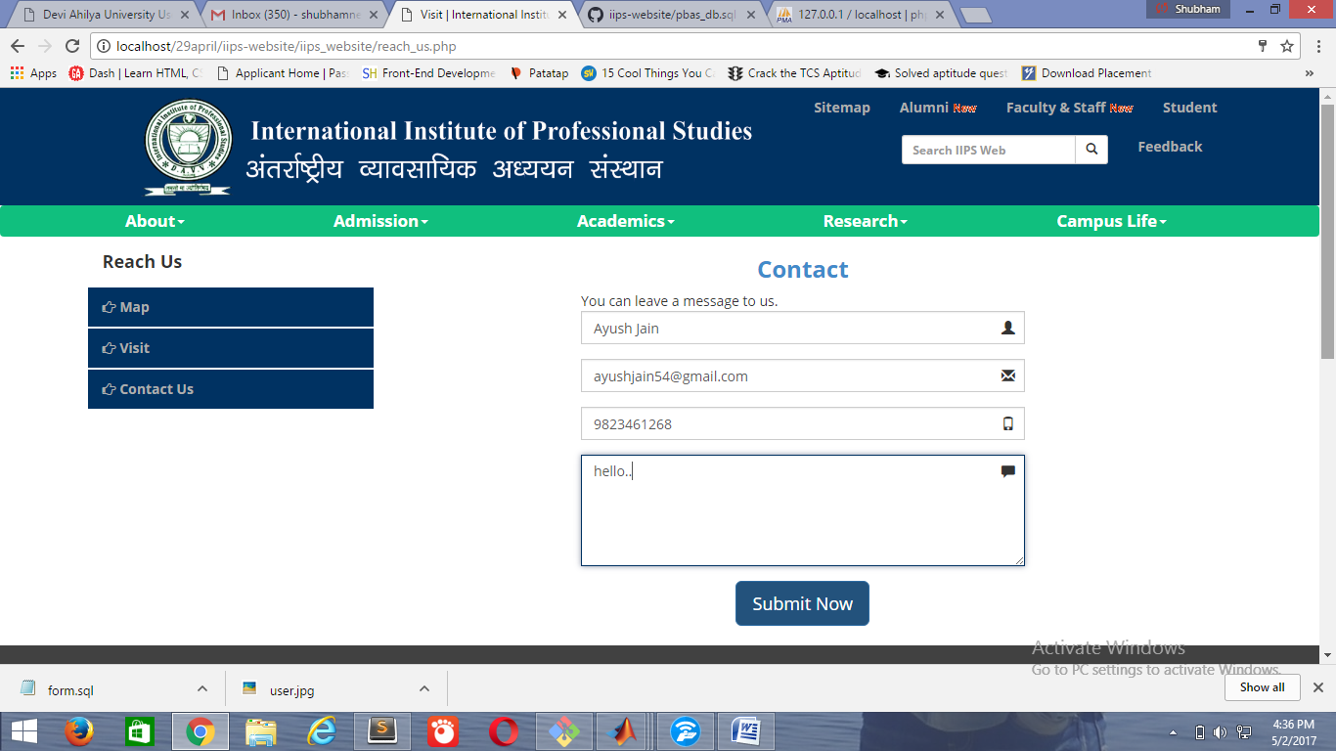

**8. SYSTEM CODING AND IMPLEMENTATION**

**Research Publication And Academic Contribution**

<?php

session_start();

if(!isset($_SESSION['username']))

{

echo "<script>window.open('index.php','_self')</script>";

}

else

{

$username= $_SESSION['username'];

?>

<!DOCTYPE html>

<html lang="en">

<head>

<meta charset="utf-8">

<meta http-equiv="X-UA-Compatible" content="IE=edge">

<meta name="viewport" content="width=device-width, initial-scale=1">

<link rel="shortcut icon" href="images/favicon.jpg">

<title>Research publication | International Institute of Professional Studies, Devi Ahilya Vishwavidhalay</title>

<!-- Bootstrap -->

<link href="css/bootstrap.min.css" rel="stylesheet">

<link href="css/newfile.css" rel="stylesheet">

<link href="font-awesome/css/font-awesome.css" rel="stylesheet" type="text/css">

<link href="yamm/yamm.css" rel="stylesheet">

<link href="css/footer.css" rel="stylesheet">

<link href='https://fonts.googleapis.com/css?family=Open+Sans:400,700' rel='stylesheet' type='text/css'>

<!-- Include Required Prerequisites -->

<script type="text/javascript" src="//cdn.jsdelivr.net/jquery/1/jquery.min.js"></script>

<script type="text/javascript" src="//cdn.jsdelivr.net/momentjs/latest/moment.min.js"></script>

<link rel="stylesheet" type="text/css" href="//cdn.jsdelivr.net/bootstrap/3/css/bootstrap.css" />

<!-- Include Date Range Picker -->

<script type="text/javascript" src="//cdn.jsdelivr.net/bootstrap.daterangepicker/2/daterangepicker.js"></script>

<link rel="stylesheet" type="text/css" href="//cdn.jsdelivr.net/bootstrap.daterangepicker/2/daterangepicker.css" />

<script language="javascript">

function getData(fileName, contentPan){

$("#"+contentPan).html("loading data......");

$.ajax({

url: fileName,

type: "post",

success: function(msg){

$("#"+contentPan).html(msg).show(500);

}

}); //End of .ajax

}

</script>

</head>

<body>

<?php include 'header.php';

?>

<div class="container">

<div class="row , minlength">

<div class="col-md-3" id="sidebar">

<ul class="nav nav-stacked" role="tablist">

<li class="navbar-brand"> <b></b> </li>

<li role="presentation" id="colm" onClick="getData('research_publication/ppij/ppij.php', 'tab1')"><a href="#tab1" aria-controls="tab1" role="tab" data-toggle="tab"><span class="fa fa-hand-o-right"></span>&nbsp;Published Papers in Journals</a></li>

<li role="presentation" id="colm" onClick="getData('research_publication/abp/apb.php', 'tab1')"><a href="#tab1" aria-controls="tab1" role="tab" data-toggle="tab"><span class="fa fa-hand-o-right"></span>&nbsp;Articles / Chapters published in Books</a></li>

<li role="presentation" id="colm" onClick="getData('research_publication/fcp/fcp.php', 'tab1')"><a href="#tab1" aria-controls="tab1" role="tab" data-toggle="tab"><span class="fa fa-hand-o-right"></span>&nbsp;Full Papers in Conference Proceedings</a></li>

<li role="presentation" id="colm" onClick="getData('research_publication/bpe/bpe.php', 'tab1')"><a href="#tab1" aria-controls="tab1" role="tab" data-toggle="tab"><span class="fa fa-hand-o-right"></span>&nbsp;Books Published as Single Author or as a Editor</a></li>

<li role="presentation" id="colm" onClick="getData('research_publication/opc/opc.php', 'tab1')"><a href="#tab1" aria-controls="tab1" role="tab" data-toggle="tab"><span class="fa fa-hand-o-right"></span>&nbsp;Ongoing Projects / Consultancies</a></li>

<li role="presentation" id="colm" onClick="getData('research_publication/cpc/cpc.php', 'tab1')"><a href="#tab1" aria-controls="tab1" role="tab" data-toggle="tab"><span class="fa fa-hand-o-right"></span>&nbsp;Completed Projects / Consultancies</a></li>

<li role="presentation" id="colm" onClick="getData('research_publication/researchguidance/researchguidance.php', 'tab1')"><a href="#tab1" aria-controls="tab1" role="tab" data-toggle="tab"><span class="fa fa-hand-o-right"></span>&nbsp;Research Guidance</a></li>

<li role="presentation" id="colm" onClick="getData('research_publication/trainingcoursefdp/trainingcoursefdp.php', 'tab1')"><a href="#tab1" aria-controls="tab1" role="tab" data-toggle="tab"><span class="fa fa-hand-o-right"></span>&nbsp;Training Courses , Teaching-Learning-Evaluation Technology, Faculty Development Programmes</a></li>

<li role="presentation" id="colm" onClick="getData('research_publication/paperpresented/paperpresented.php', 'tab1')"><a href="#tab1" aria-controls="tab1" role="tab" data-toggle="tab"><span class="fa fa-hand-o-right"></span>&nbsp;Papers Presented in Conferences, Seminars, Workshops, Symposia</a></li>

<li role="presentation" id="colm" onClick="getData('research_publication/invitedlecture/invitedlecture.php', 'tab1')"><a href="#tab1" aria-controls="tab1" role="tab" data-toggle="tab"><span class="fa fa-hand-o-right"></span>&nbsp;Invited Lectures and Chairmanship at National or International Conference/ Seminar</a></li>

</ul>

</div>

<div class="col-md-9">

<div class="tab-content">

<div role="tabpanel" class="tab-pane active" id="tab1">

</div>

</div>

<br><br>

</div><!--End Col-md-9> -->

</div>

</div>

<br>

<?php include 'footer.php';

} //else

?>

**Published Papers in Journals**

**ppij.php**

<?php

session_start();

if(!isset($_SESSION['username']))

{

echo "<script>window.open('../../index.php','_self')</script>";

}

else

{

$username= $_SESSION['username'];

?>

<script language="javascript">

$(document).ready(function()

{

$("#table_div").html("loading data");

$.ajax({

url: "research_publication/ppij/ppij_select_db.php",

type: "post",

data: { },

success: function(msg)

{

$("#table_div").html(msg).show(500);

}

});//end of ajax

}); //end of ready

$("#ppij_save").submit(function(event){

/* stop form from submitting normally */

event.preventDefault();

var values = $(this).serialize();

//alert(values);

if($("#ppij_submit").val()=="Save"){

$.ajax({

url: "research_publication/ppij/ppij_insert_db.php",

type: "post",

data: values,

success: function()

{

alert("Data Added Successfully.");

$("#twno").val("");

$("#PPIJ_Journal").val("");

$("#PPIJ_ISBN").val("");

$("#PPIJ_PRY").val("");

$("#PPIJ_PRN").val("");

$("#PPIJ_IF").val("");

$("#PPIJ_NCA").val("");

$("#PPIJ_Y").val("");

$("#PPIJ_N").val("")

//alert(values);

$("#table_div").html("Loading Data.......");

$.ajax({

url: "research_publication/ppij/ppij_select_db.php",

type: "post",

data: {},

success: function(msg)

{

$("#table_div").html(msg).show(500);

}

});//

}//end of function

}); //End of .ajax

}//end of if

else if($("#ppij_submit").val()=="Update")

{

var session_des = $(this).attr("id");

$.ajax({

url: "research_publication/ppij/ppij_update.php",

type: "post",

data: values,

success: function()

{

alert("Data Updated Successfully.");

$("#session").val("");

$("#twno").val("");

$("#PPIJ_Journal").val("");

$("#PPIJ_ISBN").val("");

$("#PPIJ_PRY").val("");

$("#PPIJ_PRN").val("");

$("#PPIJ_IF").val("");

$("#PPIJ_NCA").val("");

$("#PPIJ_Y").val("");

$("#PPIJ_N").val("")

$("#table_div").html("Loading Data.......");

$.ajax({

url: "research_publication/ppij/ppij_select_db.php",

type: "post",

data: {},

success: function(msg)

{

$("#table_div").html(msg).show(500);

}

});//

}//end of function

}); //End of .ajax

}

});

</script>

<center id="slide_up"><h4><b>Research Publication And Academic Contribution</b></h4></center>

<div class="row-fluid">

<div class="col-md-11">

<!--Published Papers Panel started -->

<div class="panel panel-primary" style="padding:3px 3px 3px 3px;">

<div class="panel-heading">

<h3 id="papers" class="panel-title" align="center">Published Papers in Journals</h3>

</div><!--end of panel heading-->

<br>

<form role="form" id="ppij_save" name="ppij_save" method="post">

<label>Session</label>

<select id="" style="width: 220px">

<?php

include('../../DBConnect.php');

//$uname=$_SESSION['username'];

$query = mysqli_query($conn,"SELECT session_description from session_master");

while($row = mysqli_fetch_assoc($query)){

?>

<option name="session" id="<?php echo $row["session_description"]; ?>" ><?php echo $row['session_description']; ?></option>

<?php } ?>

</select>

</br>

<div class="form-group">

<div id="ppij">

<label>Title With Page Numbers</label>

<input type="text" class="form-control required" name="PPIJ_TNO" id="twno" autofocus required="required"/>

<label>Journal</label>

<input type="text" class="form-control required" id="PPIJ_Journal" name="PPIJ_Journal" required="required"/>

<label>ISSN / ISBN No. </label>

<input type="text" class="form-control required" id="PPIJ_ISBN" name="PPIJ_ISBN" required="required"/><br>

<div class="row">

<div class="col-md-4">

<label> Whether peer reviewed?</label><br>

<input type="radio" value="Yes" name="PPIJ_PR" id="PPIJ_PRY" required="required">Yes <input type="radio" value="No" id="PPIJ_PRN" name="PPIJ_PR" required="required"/>NO

<br><br>

</div>

<div class="col-md-8">

<label>If peer reviewed Write the Impact factor, Else Write NIL</label>

<input type="text" class="form-control required" name="PPIJ_IF" id="PPIJ_IF" required="required"/>

</div>

</div>

<label>No. of Co-authors</label>

<input type="number" size="15" class="form-control required" name="PPIJ_NCA" id="PPIJ_NCA" required="required"/>

<br/>

<label>Whether you are the main Author</label>

<input type="radio" value="Yes" name="PPIJ_YN" id="PPIJ_Y" required="required">Yes <input type="radio" value="No" id="PPIJ_N" name="PPIJ_YN" required="required"/>NO<br />

</div> <br>

<input class="btn btn-primary" type="submit" value="Save" id="ppij_submit" name="ppij_submit"/>

<!-- <input type="submit" class="btn btn-primary" value="Delete" name="ppij_delete" /> -->

<input type="reset" class="btn btn-primary" value="Reset" name="reset" onClick="getDataTable('ppij_select_db.php','tab1')" />

</div>

</form>

</div><!--end of panel div-->

</div><!--End Of row-fluid Class -->

<!-- Table -->

<div class="view">

<div class="full col-sm-12" id="table_div">

</div>

</div>

<!-- Tabssle End -->

<div id="temp">

</div>

<?php

} //else

?>

**ppij_insert_db.php**

<?php

session_start();

if(!isset($_SESSION['username']))

{

echo "<script>window.open('../../index.php','_self')</script>";

}

else

{

$conn = mysqli_connect('localhost','root','','pbas_db');

if($conn) {

$User_Id = $_SESSION['username'];

$session = $_POST["session"];

$title = $_POST['PPIJ_TNO'];

$journal = $_POST['PPIJ_Journal'];

$issn = $_POST['PPIJ_ISBN'];

$review = $_POST['PPIJ_PR'];

$coauthor = $_POST['PPIJ_NCA'];

$mainauthor = $_POST['PPIJ_YN'];

$factor = $_POST['PPIJ_IF'];

$var = "INSERT INTO `teach_ppij` (Session, User_Id , Teach_PPIJ_TNO, Teach_PPIJ_Journal, Teach_PPIJ_ISBN, Teach_PPIJ_PR,Teach_PPIJ_NCA, Teach_PPIJ_MA, Teach_PPIJ_IF, Data_Set) VALUES ('$session','$User_Id', '$title','$journal','$issn','$review','$coauthor','$mainauthor', '$factor', 'new')";

if(mysqli_query($conn ,$var)){

// exit();

echo "Record Submitted";

}else{

echo "<script>alert('Record not Submitted') </script>";

}

}

else {

echo "not conncted";

}

}//else session

?>

**ppij_select_db.php**

<?php

session_start();

if(!isset($_SESSION['username']))

{

echo "<script>window.open('../../index.php','_self')</script>";

}

else

{

$username= $_SESSION['username'];

?>

<style>

.edit_data{

}.view_data{

}

.button_style{

padding: 4px 12px;

text-align: center;

display: inline-block;

font-size: 12px;

}

</style>

<script type="text/javascript">

$(document).on('click', '.edit_data', function(){

var ppij_id = $(this).attr("id");

$.ajax({

url:"research_publication/ppij/ppij_update_fetch.php",

method:"POST",

data:{ppij_id:ppij_id},

success: function(msg)

{

var $getarray = jQuery.parseJSON(msg);

$('#PPIJ_ID').val($getarray.PPIJ_ID);

$('#session').val($getarray.Session);

$('#twno').val($getarray.Teach_PPIJ_TNO);

$('#PPIJ_Journal').val($getarray.Teach_PPIJ_Journal);

$('#PPIJ_ISBN').val($getarray.Teach_PPIJ_ISBN);

if($getarray.Teach_PPIJ_PR=="Yes")

$("#PPIJ_PRY").prop('checked', true);

else

$("#PPIJ_PRN").prop('checked', true);

$('#PPIJ_IF').val($getarray.Teach_PPIJ_IF);

$('#PPIJ_NCA').val($getarray.Teach_PPIJ_NCA);

if($getarray.Teach_PPIJ_MA=="Yes")

$("#PPIJ_Y").prop('checked', true);

else

$("#PPIJ_N").prop('checked', true);

$('#ppij_submit').val("Update");

}

,error: function (xhr, status) {

alert(status);

}

});

}); //End ofClick and function

//end of ready

$(document).on('click', '.view_data', function(){

var ppij_id = $(this).attr("id");

$.ajax({

url:"research_publication/ppij/ppij_fetch.php",

method:"POST",

data:{ppij_id:ppij_id},

success: function(msg)

{

var $getarray = jQuery.parseJSON(msg);

$('#2').val($getarray.Session);

$('#3').val($getarray.Teach_PPIJ_TNO);

$('#4').val($getarray.Teach_PPIJ_Journal);

$('#5').val($getarray.Teach_PPIJ_ISBN);

$('#6').val($getarray.Teach_PPIJ_PR);

$('#7').val($getarray.Teach_PPIJ_IF);

$('#8').val($getarray.Teach_PPIJ_NCA);

$('#9').val($getarray.Teach_PPIJ_MA);

//alert($getarray.PPIJ_ID);

$('#ViewModal').modal('show');

}

,error: function (xhr, status) {

alert(status);

}

});

}); //End ofClick and function

$(document).on('click', '.delete_data', function(){

var ppij_id = $(this).attr("id");

$.ajax({

url:"research_publication/ppij/ppij_delete.php",

method:"POST",

data:{ppij_id:ppij_id},

success: function(msg)

{

//alert("Data Deleted");

$("#table_div").html("Loading Data.......");

$.ajax({

url: "research_publication/ppij/ppij_select_db.php",

type: "post",

data: {},

success: function(msg){

$("#table_div").html(msg).show(500);

}

});//end of ajax

} //end of success

,error: function (xhr, status) {

alert(status);

}

});

}); //End ofClick and function

</script>

<center style="height: 400px; overflow: scroll;"><h3>Your Inserted Data</h3>

<table class ="table table-striped" id="table_div" style="border-color:#337ab7;" align="center" border="1px" >

<tr>

<th>Serial No.</th>

<th>Session Year</th>

<th>Title</th>

<th>Journal</th>

<th>View</th>

<th>Delete</th>

<th>Update</th>

</tr>

<?php

mysql_connect('localhost','root','');

mysql_select_db('pbas_db');

$query= "SELECT * FROM teach_ppij WHERE User_Id = '$username' AND (Data_Set='new' OR Data_Set='valid') ORDER BY PPIJ_ID DESC";

$run= mysql_query($query);

if (!$run) { // add this check.

die('Invalid query: ' . mysql_error());

}

$serial_no = 0;

while($row=mysql_fetch_array($run)){

$session= $row['Session'];

$serial_no++;

$user_id= $row['User_Id'];

$ppij_id= $row['PPIJ_ID'];

$TNO= $row['Teach_PPIJ_TNO'];

$Journal= $row['Teach_PPIJ_Journal'];

$ISBN= $row['Teach_PPIJ_ISBN'];

$PR= $row['Teach_PPIJ_PR'];

$IF= $row['Teach_PPIJ_IF'];

$NCA= $row['Teach_PPIJ_NCA'];

$MA= $row['Teach_PPIJ_MA'];

?>

<font size="5" color="red">

<?php echo @$_GET['deleted']; ?>

</font>

<tr align="center">

<td><?php echo $serial_no; ?></td>

<td><?php echo $session; ?></td>

<td><?php echo $TNO; ?></td>

<td><?php echo $Journal; ?></td>

<td><button type="submit" name="view" id="<?php echo $row["PPIJ_ID"]; ?>" class="btn btn-success btn-xs view_data button_style" style="">View</button></a></td>

<td><button type="submit" id="<?php echo $row["PPIJ_ID"]; ?>" name="infodelete" class="btn btn-warning btn-xs delete_data button_style ">Delete</button></td>

<td><a href="#slide_up"><button name="edit" value="Edit" id="<?php echo $row["PPIJ_ID"]; ?>" class="btn btn-info btn-xs edit_data button_style">Update</button></a></td>

</tr>

<?php

}

?>

</table>

</center>

<div class="modal fade" id="ViewModal" tabindex="-1" role="dialog" aria-labelledby="myModalLabel" aria-hidden="true">

<div class="modal-dialog">

<div class="modal-content">

<div class="modal-header text-center">

<button type="button" class="close" data-dismiss="modal" aria-hidden="true">&times;</button>

<h4 class="modal-title">Details of your inserted data.</h4>

</div>

<div class="modal-body ">

<form class="form-horizontal" role="form">

<div class="col-md-3">

<label>Session</label></br>

</div>

<div class="col-md-9">

<input type="text" class="form-control required" name="" id="2" placeholder="" disabled="disabled" /></br>

</div>

<div class="col-md-3">

<label>Title With Page Numbers</label></br>

</div>

<div class="col-md-9">

<input type="text" class="form-control required" name="" id="3" placeholder="" disabled="disabled" /></br>

</div>

<div class="col-md-3">

<label>Journal</label></br>

</div>

<div class="col-md-9">

<input type="text" class="form-control required" name="" id="4" placeholder="" disabled="disabled" /></br>

</div>

<div class="col-md-3">

<label>ISSN / ISBN No.</label></br>

</div>

<div class="col-md-9">

<input type="text" class="form-control required" name="" id="5" placeholder="" disabled="disabled" /></br>

</div>

<div class="col-md-3">

<label>Peer Reviewed</label></br>

</div>

<div class="col-md-9">

<input type="text" class="form-control required" name="" id="6" placeholder="" disabled="disabled" /></br>

</div>

<div class="col-md-3">

<label>Impect Fector</label></br>

</div>

<div class="col-md-9">

<input type="text" class="form-control required" name="" id="7" placeholder="" disabled="disabled" /></br>

</div>

<div class="col-md-3">

<label>No. of Co-authors</label></br>

</div>

<div class="col-md-9">

<input type="text" class="form-control required" name="" id="8" placeholder="" disabled="disabled" /></br>

</div>

<div class="col-md-3">

<label>Whether you are the main Author</label></br>

</div>

<div class="col-md-9">

<input type="text" class="form-control required" name="" id="9" placeholder="" disabled="disabled" /></br>

</div>

<div class="form-group">

<div class="col-lg-offset-6 col-lg-6">

<button type="button" class="btn btn-large btn-primary" data-dismiss="modal">Close</button>

</div>

</div>

</form>

</div>

</div><!-- /.modal-content -->

</div><!-- /.modal-dialog -->

</div><!-- /.modal -->

<?php

} //else

?>

**ppij_update.php**

<?php

session_start();

if(!isset($_SESSION['username']))

{

echo "<script>window.open('../../index.php','_self')</script>";

}

else

{

mysql_connect('localhost','root','');

mysql_select_db('pbas_db');

$query1 = mysql_query("UPDATE `teach_ppij` SET Data_Set='updated' where PPIJ_ID='".$_POST["ppij_id"]."' ");

include "ppij_insert_db.php";

}//else

?>

**ppij_update_fetch.php**

<?php

session_start();

if(!isset($_SESSION['username']))

{

echo "<script>window.open('../../index.php','_self')</script>";

}

else

{

$connect = mysqli_connect("localhost", "root", "", "pbas_db");

$query1 = "SELECT * FROM teach_ppij where PPIJ_ID='".$_POST["ppij_id"]."'";

$query2 = "UPDATE teach_ppij SET Data_Set='updated' WHERE PPIJ_ID='".$_POST["ppij_id"]."'";

$result1 = mysqli_query($connect, $query1);

$result2 = mysqli_query($connect, $query2);

if(!$result1 && !$result2)

die("Query to show");

else if ($result1 && $result2){

$row = mysqli_fetch_assoc($result1);

echo json_encode($row);

}

} //else session

//mysql_close($connect);

?>

**ppij_delete,php**

<?php

session_start();

if(!isset($_SESSION['username']))

{

echo "<script>window.open('../../index.php','_self')</script>";

}

else

{

mysql_connect('localhost','root','');

mysql_select_db('pbas_db');

$delete_ppij_id=$_POST["ppij_id"];

$query1 = mysql_query("UPDATE `teach_ppij` SET Data_Set='deleted' where PPIJ_ID='$delete_ppij_id' ");

} //else session

?>

**9. OUTPUT FORMS AND REPORT**

**10.TESTING**

**TESTING**





In PBAS , we have used various Testing types , Testing methods, Testing techniques to test the system for efficient functionality

.

10.1 Testing Scenario include as follow:-

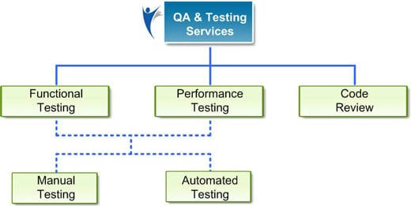

|  |  |  |  |
| --- | --- | --- | --- |
| **Testing** | **White Box Testing** | **Black Box Testing** | **Technique**  **Used** |
| **Unit Testing** | Unit Testing done individually by developer in Code. Unit Testing is done in :  (Login, Profile Page, Research_pub , Alumni, Co-curricular, PDF report, overview, Gmail login )  Done By : RitikaBarethia , Sweta Rathore, Shubham Neema , Vikas Chouhan. | Unit Testing done individually by developer by giving input and validate output. Unit Testing is done in :  (Login, Profile Page, Research_pub , Alumni, Co-curricular, PDF report, overview, Gmail login )  Done By : Ritika Barethia , Sweta Rathore , Shubham Neema , Vikas Chouhan. | 1. Equivalence Partition. 2. Statement Coverage. 3. Code Coverage. 4. Data Flow 5. Path coverage |
| **Integration Testing** | Integration testing done by Integrating all different modules(Profile Page, Researchpub , Co-curricular , pdf report, overview) by reviewing Code. | Integration testing done by Integrating all different modules(Profile Page, Research_pub , Co-curricular , pdf report, overview) by giving valid and invalid inputs and corresponding its validate output. | **(Approaches)**   1. Top Down. |
| **System Testing** | System Testing done by validating the all modules by verifying the code. | System Testing done by validating the all modules by giving valid and invalid inputs and corresponding its validate output.. | **(Verifiy)**  1. Functional   1. Non functional Requirement |
| **Regression**  **Testing** | Regression Testing is done by validating all the module by code to see the side effects if any.  (Automation testing By Sweta Rathore) | Regression Testing is done by giving valid input and verify output to verify any side effect if required.  (Automation testing By Sweta Rathore, Ritika Barethia) | **Tools Used:**  Selenium .  Test Data.  Test Cases Execution. |
| **Acceptance Testing** | Acceptance Testing is done by reviewing it to Users. | Acceptance Testing is done by reviewing it to Users by valid and invalid inputs to verify valid output. | By reviewing System to Users manually filling the form. |



**10.2** **TEST CASES :**

**TestCase of Login ; (To verify Login Module with valid User_id and Password.)** 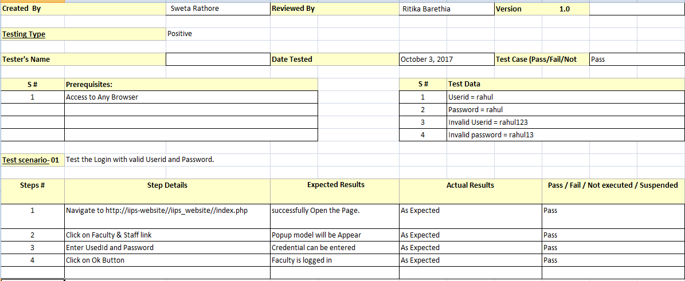



**TestCase of Login : (To verify Login Module with invalid User_id and invalid Password.)**

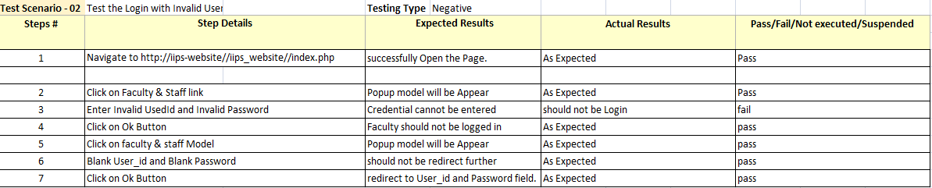

**TestCase of Profile Page :**

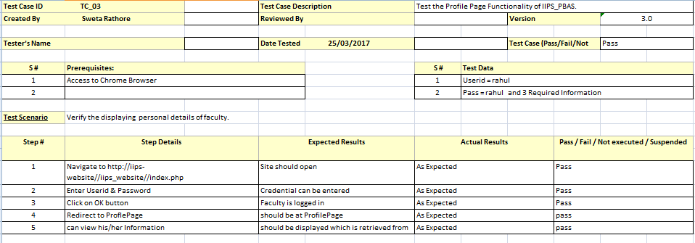

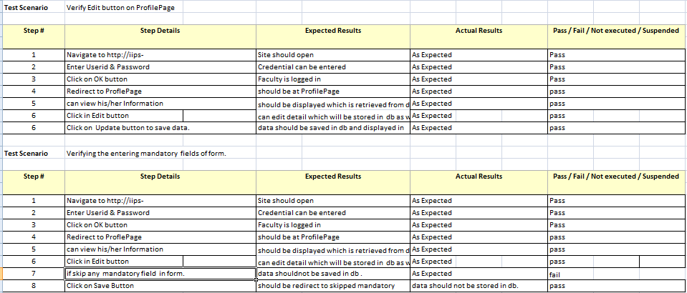

**TestCase : to verify Save, update, delete and View Button**

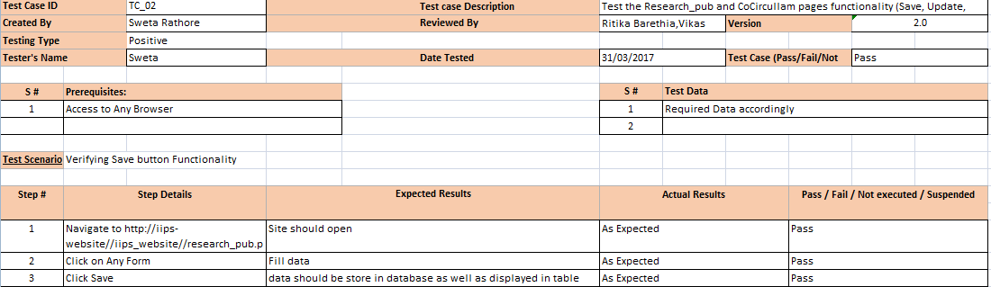

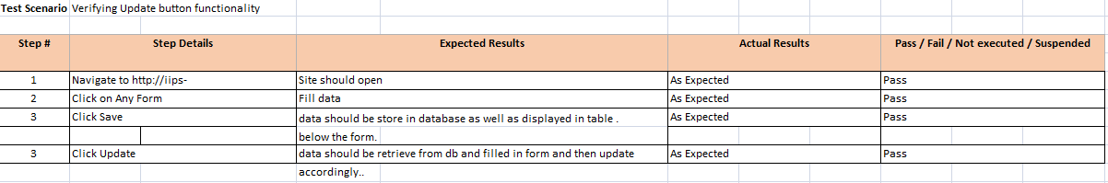

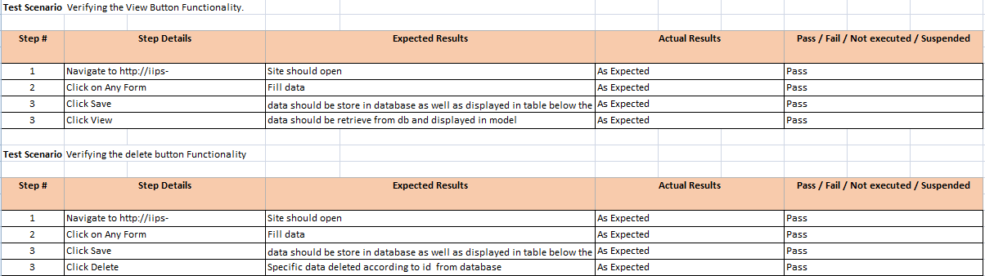

**10.3 Bug Report**

During development phase various bug were reported by tester , to enhance the effectiveness of System . Different Module Bug Report presented below:

**Defeat Report for (Not appropriate title)**

|  |  |
| --- | --- |
| **Defect ID:** | 01 |
| **Author:** | Sweta Rathore |
| **Release/Build** | Co-Curricular Form |
| **Open Date:** | 22/04/2017 |
| **Close Date** | 26/04/2017 |
| **Problem Area** | Co-Curricular link |
| **Defect or Enhancement:** | Defect |
| **Problem Title:** | Not appropriate titles. |
| **Problem Description:** | Subtitle is irrelevant according Co-Curricular Link. |
| **Current Environment:** | Win7/WAMP Server/Any Browser |
| **Other Environment(s):** | Win7/WAMP Server/Any Browser |
| **Defect Type:** | Functionality , Usability |
| **Who Detected:** | Faculty |
| **How Detected:** | Alpha Testing  Review |
| **Assigned To:** | Vikas Chouhan |
| **Priority:** | High |
| **Severity:** | Low |
| **Status:** | Being Reviewed by Development |
| **Fixed by:** | Vikas Chouhan |

**2 . Defeat Report of Session save.**

|  |  |
| --- | --- |
| **Defect ID:** | 03 |
| **Author:** | Ritika Barethia |
| **Release/Build** | Session log |
| **Open Date:** | 1/04/2017 |
| **Close Date:** | 29/04/2017 |
| **Problem Area:** | Session Problem. |
| **Defect or Enhancement:** | Enhancement |
| **Problem Title:** | Session not maintained. |
| **Problem Description:** | Session is not maintained properly. |
| **Current Environment:** | Win7/8/10, WAMP Server/Any Browser. |
| **Other Environment(s)** | Win7/8/10, WAMP Server/Any Browser. |
| **Defect Type:** | Functionality |
| **Who Detected:** | Development |
| **How Detected:** | Review  Walkthrough |
| **Assigned To** | Shubham Neema |
| **Priority:** | High |
| **Severity:** | High |
| **Status:** | Open |
| **Status Description:** | Not Fixed |
| **Fixed by:** | Not Fixed |

1. **Defeat Report of Profile Page**

|  |  |
| --- | --- |
| **Defect ID:** | 02 |
| **Author:** | Sweta Rathore |
| **Release/Build** | Profile Page (profile.php) |
| **Open Date** | 20/03/2017 |
| **Close Date:** | 20/04/2017 |
| **Problem Area:** | Profile Page of Faculty |
| **Defect or Enhancement:** | Defect |
| **Problem Title:** | to save data need to fill it twice. |
| **Problem Description** | To save information in db as well as to display, need to fill it twice in form. |
| **Current Environment:** | Win7/8/10, WAMP/ Any Browser. |
| **Other Environment(s):** | Win7/8/10, WAMP/ Any Browser. |
| **Defect Type:** | Database Integrity  Performance |
| **Who Detected:** | Development |
| **How Detected:** | Review |
| **Assigned To** | Sweta Rathore , Shubham Neema. |
| **Priority:** | Critical |
| **Severity:** | Critical |
| **Status** | Ready for Testing in the Next Build |
| **Status Description:** | “Ready for Testing in the Next Build” |
| **Fixed by:** | Shubham Neema and Sweta |

1. **Defeat Report Of Profile Page disability**

|  |  |
| --- | --- |
| **Defect ID:** | 05 |
| **Author:** | Sweta Rathore |
| **Release/Build #** | Profile Page |
| **Open Date:** | 26/04/2017 |
| **Close Date:** | 29/04/2017 |
| **Problem Area:** | Profile Form Name disable. |
| **Defect or Enhancement:** | Defect |
| **Problem Title:** | Disability of Name Field |
| **Problem Description:** | When Faculty fill the form , name field should be disable by default. |
| **Current Environment:** | Win7/8/10, WAMP Server, Any Browser |
| **Other Environment(s)** | Win7/8/10, WAMP Server, Any Browser |
| **Defect Type:** | Usability |
| **Who Detected:** | Quality Assurance |
| **How Detected:** | Walkthrough |
| **Assigned To:** | Ritika Barethia |
| **Priority:** | Medium |
| **Severity:** | Low |
| **Status:** | Open (Default) |
| **Status Description:** | Solved |
| **Fixed by:** | Ritika Barethia |

**Defeat Report in Ongoing Project Form**

|  |  |
| --- | --- |
| **Defect ID:** | 04 |
| **Author:** | Ritika Barethia |
| **Release/Build** | Research_publication |
| **Open Date:** | 25/03/2017 |
| **Close Date:** | 25/04/2017 |
| **Problem Area:** | Ongoing Prjoect not loading |
| **Defect or Enhancement:** | Enhancement |
| **Problem Title:** | Form not loading or appeared |
| **Problem Description:** | On clicking on Ongoing project , it is not appeared |
| **Current Environment:** | Win7/8/10, WAMP Server, Any Browser |
| **Other Environment(s):** | Win7/8/10, WAMP Server, Any Browser |
| **Defect Type:** | Functionality . |
| **Who Detected:** | Development |
| **How Detected:** | Testing |
| **Assigned To:** | Shubham Neema |
| **Priority:** | High (Default) |
| **Severity:** | High (Default) |
| **Status:** (Required) | Open (Default) |
| **Status Description:** | Open and solve it . |
| **Fixed by:** | Shubham |

**6. Defeat Report of Days/Month Clarification.**

|  |  |
| --- | --- |
| **Defect ID:** | 06 |
| **Author:** | Sweta Rathore |
| **Release/Build #** | Research Publication and Co-Curricular sub links. |
| **Open Date** | 25/03/2017 |
| **Close Date:** | 30/04/2017 |
| **Problem Area:** | Days/Month field is not clear. |
| **Defect or Enhancement:** | Enhancement |
| **Problem Title:** | Suitable Fields in forms |
| **Problem Description:** | Forms days/month field should be clear , so that faculty can fill it easily. |
| **Current Environment:** | Win7/8/10, WAMP Server, Any Browser |
| **Other Environment(s)** | Win7/8/10, WAMP Server, Any Browser |
| **Defect Type:** | Usability |
| **Who Detected:** | Development |
| **How Detected:** | Review |
| **Assigned To:** | Vikas Chouhan |
| **Priority:** | Medium |
| **Severity:** | Low |
| **Status:** | Open (Default) |
| **Status Description:** | Fixed |
| **Fixed by:** | Ritika Barethia, Vikas |

**11. FUTURE PROSPECTIVE**

**11.1 Future Prospective**



The project can be expanded further to manage the information in a very easy and convenient way:-

* System can be made online at UGC level if UGC approves the system.
* API scores can be automated.
* Submission process of performance based appraisal system can be made online if UGC approved the system.
* A general message or announcement can be informed directly on the user’s mobile or PC.
* Project can be converted to be used as a mobile application.
* Facilities can be made more integrated, safe and easy.

**12.CONCLUSION**

**BIBLOGRAPHY**

**12.1.Appendix List of abbreviation**

**12.2 Appendix B: Diagrams**

**12.3 References and Bibliography**

**12.3.1 BOOKS REFERRED**

* Elias M.Awad, System Analysis and Design,

Edition: II edition 2009

Publication: Galgotia Publication Pvt. Ltd, New Delhi.

* Pankaj Jalote, An Integrated Approach to Software Engineering

Edition: III Edition

Publication: Narosa Publishing House (for India).

**12.3.2WEBSITES REFERRED**

* <http://www.vbtutor.net/vb6/vbtutor.html>
* https://www.w3schools.com/xml/ajax_intro.asp
* <http://visualbasic.freetutes.com/learn-vb6/>
* http://php.net/manual/en/intro-whatis.php
* <http://www.youtube.com/watch?v=Adi3jwkta8o>
* <http://www.dbforums.com/microsoft-access/988090-connecting-vbulletin-6-0-ms-access.html>
* <http://www.w3school.com/>
* <http://getbootstrap.com/>